**Smart Chat:**

**Mobile App to Connect People**

Senior Project

by

**Firas Khadra**

**72030278,**

**Sadek Mhanna**

**72030823**

Submitted to the School of Engineering of the

Lebanese International University

Beirut, Lebanon

in partial fulfillment of the requirements for the degree of

**BACHELOR OF SCIENCE IN COMPUTER AND COMMUNICATION ENGINEERING**

**Summer 2023-2024**

**Approved by:**

**Supervisor**

Dr. Hussein Nasrallah

**Committee Member**

Dr. Nour Akkad

**DEDICATION**

*This project is dedicated to my beloved mother and brother, who have been my constant sources of strength and inspiration. My mother, whose love, wisdom, and endless support have shaped me into who I am today, has always been the pillar I could lean on. Her unwavering belief in my abilities has guided me through every challenge.*

*Firas Khadra*

*This project is dedicated to my incredible mother, whose unwavering support and belief in me have been my constant source of strength. To my Big Brother, whose guidance and encouragement have always been there when I needed it most. A special thanks to my amazing friends, whose encouragement and presence throughout this journey made it all possible. Your support has been invaluable at every step of the way.*

*Sadek Ali Mhanna*

**ACKNOWLEDGMENT**

We would like to express our deepest gratitude to those who have made the successful completion of the Smart Chat App project possible.

First, our sincere thanks go to our supervisor, Dr. Hussein Nasrallah, whose constant guidance and unwavering support were instrumental throughout the development of this project. His invaluable mentorship and expert advice gave us the insight and confidence to overcome challenges and achieve our goals.

We would also like to extend our heartfelt appreciation to Dr. Nour Akkad for her continuous support and exceptional teaching. Her knowledge and dedication have greatly contributed to the development of the skills needed to bring this project to life.

We would like to express our heartfelt gratitude to Dr. Ahmad Kobeissi and Dr. Hadi Noureddine for their exceptional teaching and guidance throughout our academic journey. Their dedication and expertise have been crucial in helping us develop a deep understanding of the field. A special thanks to both for teaching us everything we needed to succeed during the semesters. Their commitment to our education has had a lasting impact, and we are deeply appreciative of all they have done for us.

To these exceptional educators, we are truly grateful for your contributions and for being key figures in the success of this endeavor.

**ABSTRACT**

In today’s increasingly interconnected world, overcoming language barriers and maintaining smooth communication is more important than ever. This senior project introduces a Smart Chat App powered by AI, designed to facilitate seamless communication with real-time translation, AI-driven conversation prompts, voice calls, and autocorrection features. The app allows users to engage in text and voice conversations across different languages, automatically translating messages and spoken words in real-time. Additionally, the AI suggests intelligent prompts to guide conversations and provides autocorrection to enhance the clarity of text, ensuring more efficient and meaningful interactions. Whether for personal or professional use, this app revolutionizes the communication experience, making it easier for people from diverse linguistic backgrounds to connect effortlessly.

**TABLE OF CONTENTS**

CHAPTER 1 INTRODUCTION 1

1.1 Background 1

1.2 Problem Statement 1

1.3 General overview of the project 2

1.4 Thesis Outline 3

CHAPTER 2 Survey of Existing Methods and Similar Systems 4

2.1 Introduction 4

2.2 System 1: Discord 4

2.3 System 2: Telegram 6

2.4 System3: WhatsApp 8

2.5 Systems Comparison 10

2.6 Conclusion and Motivation 12

CHAPTER 3 System Design 14

3.1 Introduction 14

3.2 Requirements and Specification Analysis 14

3.3 Functional Requirements 15

3.4 Use Case Diagrams 16

3.5 System Architecture 17

3.6 Class Diagrams 20

3.7 Sequence Diagrams 22

3.8 Activity Diagrams 25

3.9 Entity-Relationship (ER) Diagrams 28

3.10 Non-Technical Aspects 30

1 Financial Viability 30

2 Stakeholders 31

3 Scope 32

4 Risks 33

5 Schedule and Milestones 34

6 Ethical and Social Consideration 35

7 Environmental and Sustainability Considerations 35

8 Relevant Standards 35

3.11 Conclusion 36

CHAPTER 4 Implementation/Simulation and Testing 37

4.1 Introduction 37

4.2 Implementation Tools 37

4.3 Implementation Summary 40

4.4 Test Cases and Acceptance Criteria 62

4.5 Conclusion 67

CHAPTER 5 Conclusion and Future Work 69

5.1 Conclusion 69

5.2 Future Work 70

CHAPTER 6 References 84

**LIST OF FIGURES**

Figure 2‑1 Discord Mobile 5

Figure 2‑2 Discord Chat UI 6

Figure 2‑3 Telegram Mobile Application 7

Figure 2‑4 Telegram UI Design. 8

Figure 2‑5 WhatsApp Mobile 9

Figure 2‑6 WhatsApp UI 9

Figure 3‑1 Use Case Diagram 16

Figure 3‑2 System Architecture 19

Figure 3‑3 Class Diagram 21

Figure 3‑4 User Registration and Authentication Sequence Diagram 23

Figure 3‑5 Sending a Message with AI Translation Sequence Diagram 24

Figure 3‑6 Receiving a Message Sequence Diagram 24

Figure 3‑7 User Registration Activity Diagram 26

Figure 3‑8 User Login Activity Diagram 27

Figure 3‑9 Sending a Message with AI Translation Activity Diagram 28

Figure 3‑10 Entity-Relationship Diagram 29

Figure 4‑1 Model-View-Controller Design. 41

Figure 4‑2 Overview of Firebase Services for Smart Chat App 42

Figure 4‑3 Detailed Overview of Firebase Services for Smart Chat App 43

Figure 4‑4 Registration views for Smart Chat Dark/light themes 44

Figure 4‑5 Step-by-step representation 45

Figure 4‑6 Home Page 45

Figure 4‑7 Chats, Groups, Profile, Settings Views. 46

Figure 4‑8 Selecting a user from Search Activity 47

Figure 4‑9 Chat Activity View 50

Figure 4‑10 Auto Translation Showcase. 50

Figure 4‑11 Walkthrough of sending an image 51

Figure 4‑12 Sending a contact/document process 51

Figure 4‑13 Blocking a contact. 52

Figure 4‑14 Calling feature walkthrough 53

Figure 4‑15 Speech-to-text feature. 54

Figure 4‑16 Ai prompting 54

Figure 4‑17 Creating a group chat 56

Figure 4‑18 Group video call 57

Figure 4‑19 Demo of updating the profile. 58

Figure 4‑20 Settings Fragment 60

Figure 4‑21 Changing app language functionality 61

Figure 4‑22 Logout Function 61

Figure 4‑23 The username must be greater than 3 characters. 63

Figure 4‑24 Handling the OTP code 63

Figure 4‑25 Checking if the phone number is valid 63

Figure 4‑26 Checking if the user is blocked 65

Figure 4‑27 If the user is blocked you will not be able to use the send function. 65

Figure 4‑28 If isAdmin is true the user will be able to add members to the group. 67

Figure 5‑1 Methods used to encrypt and decrypt data 73

Figure 5‑2 Sending notifications using OneSignal. 75

LIST OF TABLES

Table 1‑1: Comparison Table Based on Graphical Interfaces 11

Table 1‑2: Comparison Table Based on Content and Functionality 11

Table 1‑3: Comparison Table Based on Features 12

Table 2‑1 Cost Benefit Analysis 31

Table 2‑2 Scheduling Tasks and Milestones 34

**LIST OF SYMBOLS**

%: Percentage.

ai: Artificial intelligence.

API: Application programming interface.

app: Application.

CRUD: Create, Read, Update, Delete.

ER: Entity relationship.

MVC: Model-View-Controller.

SDK: Software development kit.

Ui: User interface.

UML: Unified Modeling Language.

WiFi: Wireless Fidelity.

# INTRODUCTION

## Background

The world has changed into a global interconnected community due to the fast development of technology, which facilitates communication between people from different cultures. The Smart Chat app is a unique way of communicating with individuals regardless of distance. This app provides many features like messaging and calls. In addition to using artificial intelligence for translation and the auto-correction of text. Moreover, users can access Gemini AI during chat without leaving the app.

In Traditional chatting apps, there is no option for translation, which makes communication between individuals with different languages difficult. Moreover, many apps ask for user's data to be shared to allow for the free use of the app, which makes it difficult for users to choose the best app for them. The Smart Chat app provides two main features, which are the use of artificial intelligence for translation and the auto-correction of text.

## Problem Statement

Nowadays, people from different countries and cultures need to communicate with each other. With each having a different language, it’s a big challenge to have clear conversations. Many users struggle when using traditional apps as they must leave the app and use different apps to translate text. Another problem that faces the users is the grammar mistakes when writing which cause embarrassment for users.

The smart chat app aims to solve these issues by using AI technology to offer better translation and correction features. Specifically, the app will improve translation accuracy using the AI to give translations that fit the context and cultural differences, making conversations clearer and more accurate.

By addressing these challenges, the smart chat app aims to enhance communication effectiveness and ease of use for individuals. While there are some translation and correction tools available, they often don’t meet the needs of users well or they are not part of the chatting apps as they are external tools.

The goal of the smart chat app is to make communicating in different languages easier and more effective. It aims to reduce misunderstandings, improve collaboration, and help people connect better across language barriers.

## General overview of the project

This project is a mobile application that utilizes databases and the Java programming language to build the app using Android Studio. The app's main service is to provide a fast and safe chatting service between users including text messages and calls. In addition to the use of artificial intelligence for the translation from one language to another and for the auto-correction of the text. The people targeted by the app are people that want to communicate with others but have the language as barrier and people that have a lot of mistakes when writing which causes them a lot of problems and embarrassment. In addition to the public that wants to chat.

This application is developed to enhance communication between users across different and same countries by providing fast and safe chat including text and messages. By adding artificial intelligence, the app offers auto translation services. This allows users to communicate with each other without the need to focus on the text mistakes regardless of their language. Overall, by combining these features, the app aims to make the process of communication more efficient to enhance the user experience for everyone involved.

## Thesis Outline

This report is structured into several chapters, each addressing a specific aspect of the project. The first chapter provides a brief introduction to chatting apps and the use of AI. It also explains why we need to use new technologies and software implementations in chatting applications. The second chapter lists to the reader the various similar systems applied in existing chatting apps. This chapter evaluates these systems based on user interface, functionality, and features. The third chapter demonstrates the UML diagrams on which this project is built, as well as technical and non-technical elements. Chapter 4 delves into the implementation tools and algorithms utilized in the development of the system. This chapter provides insights into the technical details of the Smart Chat app implementation. Finally, in Chapter 5, the report contains a conclusion as well as the future of the project.

# Survey of Existing Methods and Similar Systems

## Introduction

Nowadays, the world has transformed into a globally interconnected community due to the development of the internet and the ways of communication between people. The high demand for chatting applications with more features to facilitate people’s communication has been on the rise, creating a growing market for companies to provide better apps. As of 2023, the estimated number of internet users worldwide was 5.4 billion, up from 5.3 billion in the previous year. This share represents 67 % of the global population [1].

The high number of chatting applications available with each providing special services is becoming overwhelming for customers to choose the right one that meets their needs and expectations. Therefore, an objective review of similar systems and existing methods in the domain of chatting applications, for the user to choose the app that meets his demands by showing him the pros and cons of each system.

This chapter aims to provide a comprehensive survey of current AI-driven communication platforms, to analyze the strengths and weaknesses of current approaches and systems.

## System 1: Discord

Discord was first released in May 2015 under the domain name discordapp.com [2]. It is a direct messaging application and social platform that grants communication through text messaging, voice calls, video calls, and sharing media. The platform targeted gamers but soon expanded to be used by any community. Although the app was originally designed to target gamers [3], anyone can use it now. Discord allows integration with bots, providing features like music playback, moderation tools, and more that can improve user experience. Figure 2‑1 shows the Discord mobile application.

These AI-powered bots can carry out a variety of tasks and duties such as:

* Image generation: The Midjourney bot can be added by a user to the chatting room, a user can prompt it through the **/imagine** command [4] to generate high-quality images.
* Automatic moderation: Sven is a Discord bot that utilizes AI text and image models to detect inappropriate text and image inputs and automatically remove them [5].

However, the majority of these bots are paid or have a limited quota. While Discord is user-friendly, many beginners may find it overwhelming initially due to its extensive features and crammed UI. Figure 2‑2 is a Ui showcase.

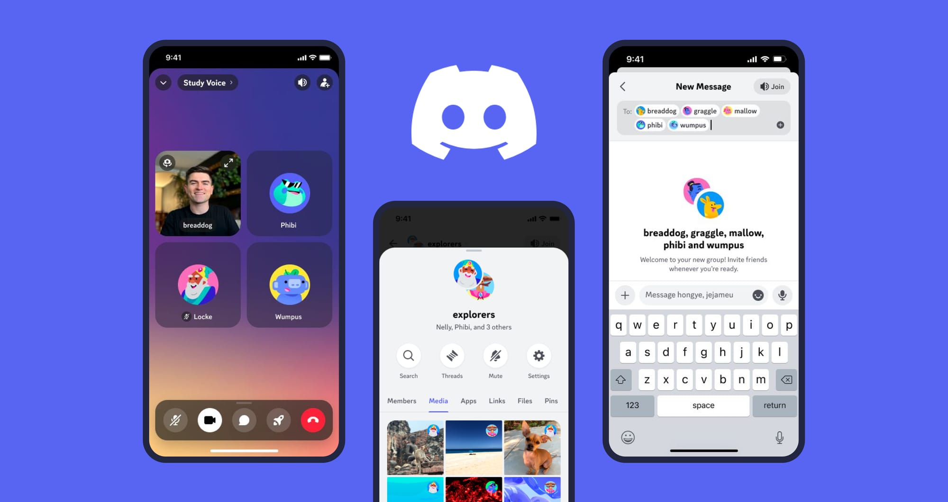

Figure 2‑1 Discord Mobile

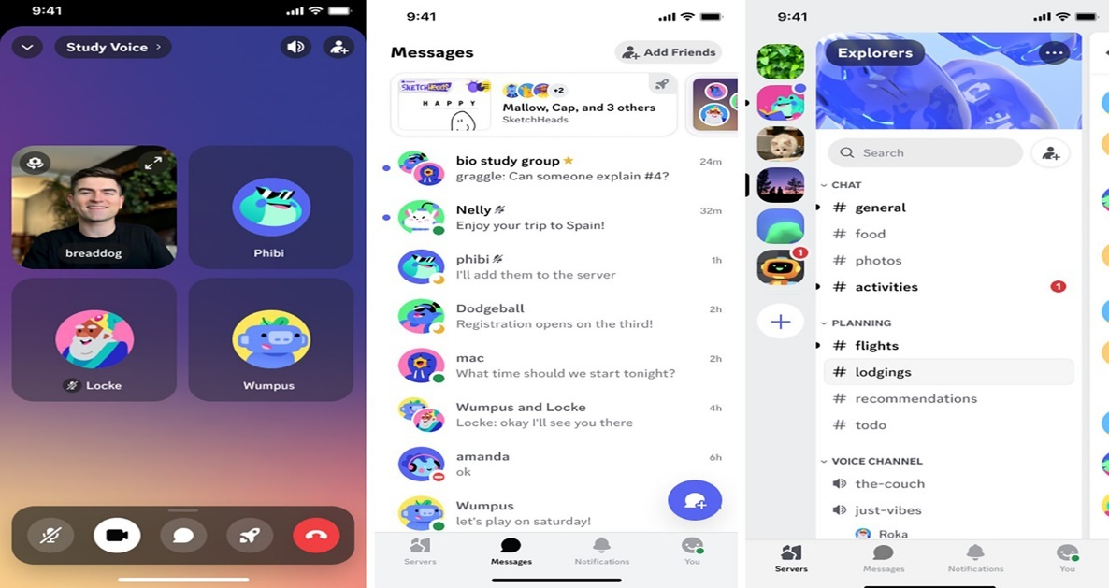

Figure 2‑2 Discord Chat UI

## System 2: Telegram

August 2013 saw the initial release of Telegram under the telegram.org domain. The messaging app Telegram is cloud-based and prioritizes security and speed. It facilitates file sharing, voice, video, and text messaging as well as other forms of communication [6]. Originally intended to provide a quick and safe chat app, Telegram has grown in popularity across several user bases, including developers, activists, and regular consumers. The Telegram smartphone application is displayed in Figure 2‑3. Figure 2‑4 shows Telegram Ui. Telegram offers a variety of features that improve user experience by integrating with bots. These AI-driven bots and integrations are capable of carrying out a wide range of duties. For example:

The first AI-driven bot is automated in Chat Management. The Rose bot can take care of user bans, automatically remove spam, and reply to preset orders in-group chats. In big gatherings, this promotes order and improves user experience [7].

Another bot is available to help with Travel Assistance. Users can get help finding flights, hotels, and travel specials with offers via the help of AI bot Eddy Travels, an AI travel bot. Eddy Travels makes travel planning easier for users by using AI to assess travel preferences and deliver personalized recommendations and real-time updates [8].

Telegram is a great tool, but its end-to-end encryption is not enabled by default [9]. To make chats safe, users must set the secret mode in the chat menu. Additionally, the data is text-based on the server, leaving it vulnerable to hackers [10].

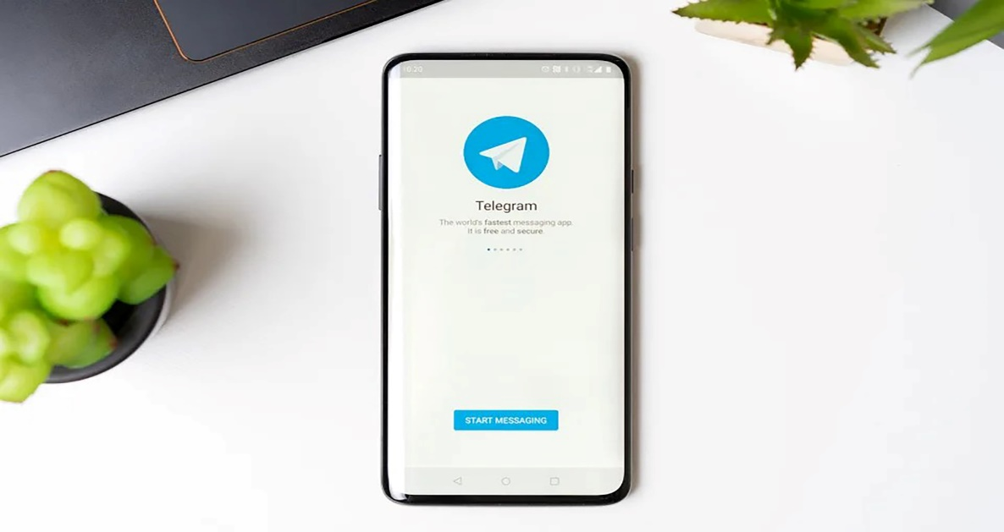

Figure 2‑3 Telegram Mobile Application

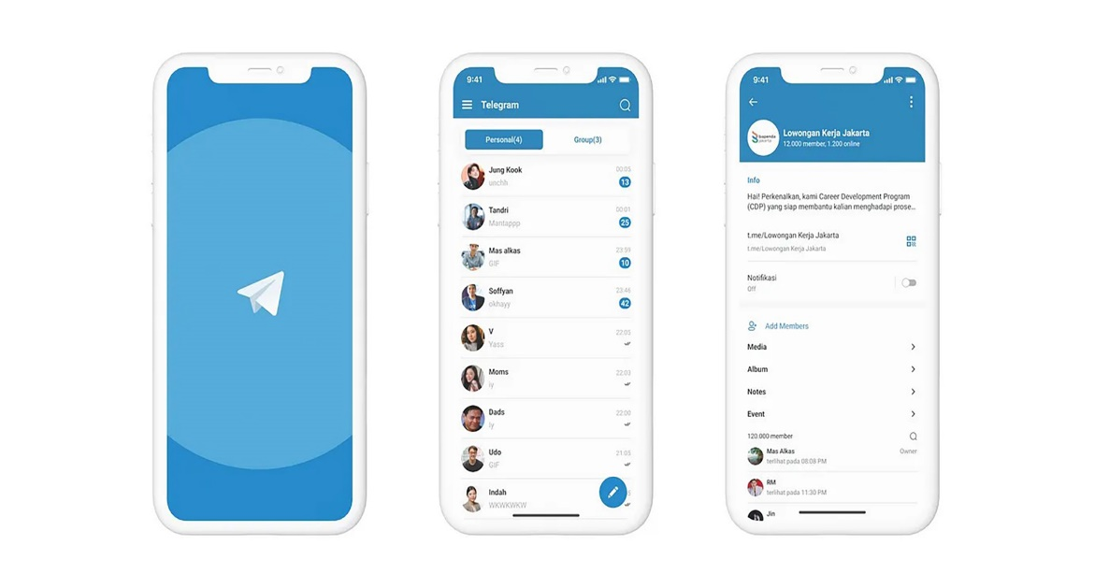

Figure 2‑4 Telegram UI Design.

## System3: WhatsApp

WhatsApp is one of the most used chatting apps, As of June 2023, WhatsApp had approximately 2.78 billion unique active users worldwide and Over 1 billion messages are sent daily through WhatsApp [11]. WhatsApp platform that enables users to exchange text messages, voice messages, images, and videos. In addition, it provides a page for updates and your friends' status. Figure 2‑5 shows WhatsApp Mobile.

One of the main features of WhatsApp is accessibility due to several factors. It is found on various platforms including Android, iOS, and web browsers, making it available for all users regardless of their device. In addition, it is free to download and use and there are no subscription fees or hidden costs. Figure 2‑6 shows WhatsApp UI design.

However, one potential drawback of WhatsApp is its privacy. WhatsApp updated its terms of use and privacy policy, primarily to expand on its practices around how WhatsApp business users can store their communications. A pop-up has been notifying users that as of February 8, the app's privacy policy will change and they must accept the terms to keep using the app [12]. This step has led many people to stop using WhatsApp and start searching for other chatting apps to use.



Figure 2‑5 WhatsApp Mobile

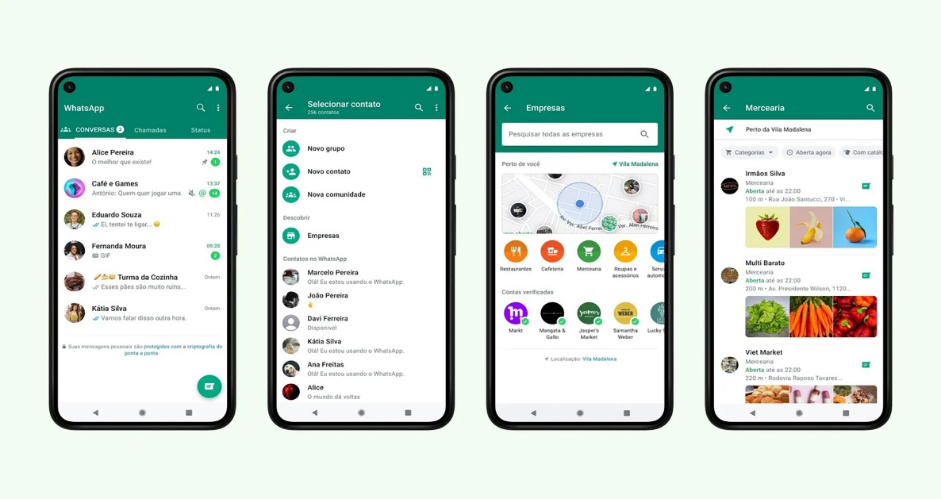

Figure 2‑6 WhatsApp UI

## Systems Comparison

Discord, Telegram, and WhatsApp are compared based on their graphical interface, content, functionality, and features, and various advantages and shortcomings become apparent.

Discord has a modern and engaging design that appeals to gamers and general users alike. It allows media embedding straight into chats and provides user-customizable themes and visual settings, including dark mode. However, due to its extensive features and options, it may become overwhelming for casual users, and in large servers with many channels, the UI may end up cluttered. Discord's content and functionality are robust, featuring voice, video, and text communication options. The platform is organized into servers with separate channels, each with a specific topic, supporting bots, and integration of various functionalities, like games, music, and moderation. It also allows screen sharing and video streaming. Some of these features require a Discord nitro subscription.

With a vast selection of themes, Telegram has an extremely flexible, simple, and minimalist appearance. Group chats and settings are easily accessible thanks to its user-friendly structure. However advanced settings are not immediately visible. Telegram shines in content and functionality with its ability to support up to 200,000 members in a single group chat. Users can access messages and media from numerous devices thanks to cloud-based storage; however, these messages are not encrypted by default due to secure chat being off by default. Despite these strong capabilities, Telegram's attractiveness for regular contact may be limited because it is less popular than major messaging apps for informal, personal use.

WhatsApp has a basic, user-friendly design that is easy to navigate, this design maintains a uniform appearance and feel across all platforms. It enables multimedia sharing within chats and allows quick access to status updates and settings. However, it has less customization than Discord and Telegram and doesn't support rich media embedding as Discord does. Regarding content and functionality, WhatsApp is noted for its end-to-end encryption, which ensures the privacy and security of all messages. It can host group chats, as well as phone and video calls. The status updates enable users to share brief stories with friends and family. While WhatsApp is extensively used worldwide, achieving ease of communication with others, it has smaller groups than Telegram. Furthermore, there are concerns about data privacy, as WhatsApp shares user data with its parent company, Meta, which might be a huge drawback for privacy-minded consumers.

Table 1‑1: Comparison Table Based on Graphical Interfaces

|  |  |  |  |
| --- | --- | --- | --- |
| **Criterion 1** | **Discord** | **Telegram** | WhatsApp |
| **Graphical Interface** |
| User interface | Intuitive | Accessible | Easy to Use |
| navigation | Troubling | Simple | Simple |
| Design | Modern | Minimalist | Professional |
| Responsive | Dynamic | Smooth | Fast |

Table 1‑2: Comparison Table Based on Content and Functionality

|  |  |  |  |
| --- | --- | --- | --- |
| **Criterion 2** | **Discord** | **Telegram** | WhatsApp |
| **Content and Functionality** |
| Quality content structure | Organized | Hierarchical | Streamlined |
| Usability | Versatile | Flexible | User-Friendly |
| Dynamic content | Interactive | Extensive | Functional |
| Content management system | Diverse | Robust | Basic |

Table 1‑3: Comparison Table Based on Features

|  |  |  |  |
| --- | --- | --- | --- |
| **Criterion 3** | **Discord** | **Telegram** | WhatsApp |
| **Features** |
| Security measures | Safe | Advanced | Encrypted |
| Third-party integration | Expansive | Expansive | Limited |
| Accessible content and location | Available | Available | Widespread |
| Registration form | Detailed | Simple | Easy |

## Conclusion and Motivation

The assessment of Discord, Telegram, and WhatsApp demonstrates each platform's strengths and drawbacks, identifying gaps and areas for improvement that inspire the creation of a new and improved chatting program.

Discord excels in providing a rich modern interface with extensive tools for media embedding, yet its complexity can be overwhelming. Telegram’s flexible design allows for significant group chat features and cloud-based storage, but it lacks default encryption for messages and is not as popular for personal usage. WhatsApp noted for its simplicity and global use, has robust encryption and ease of communication but lacks customization and has prompted data privacy issues due to its data-sharing practices.

The comparison of Discord, Telegram, and WhatsApp demonstrates each platform's strengths and drawbacks, identifying gaps and areas for improvement that inspire the creation of a new and improved chatting program.

Discord excels in providing a rich modern interface with extensive tools for media embedding, yet its complexity can be overwhelming. Telegram’s flexible design allows for significant group chat features and cloud-based storage, but it lacks default encryption for messages and is not as popular for personal usage. WhatsApp noted for its simplicity and global use, has robust encryption and ease of communication but lacks customization and has prompted data privacy issues due to its data-sharing practices.

Given these observations, our work aims to create a chat application that combines the greatest aspects of these platforms while resolving their faults. This new system should have the following specifications:

1. User-Friendly Interface: a straightforward interface that balances simplicity with advanced features. Making it useful for casual and power users.
2. Enhanced Security: End-to-end encryption for all messages, ensuring robust privacy.
3. Privacy-Focused: Strict data privacy policies that do not involve sharing user data with third parties, addressing the concerns raised by existing methods.

Existing systems fail to address the following issues: lack of default chat security (Telegram), the potential complexity of the UI (Discord), and data privacy concerns (WhatsApp). By creating a new chatting application that implements the best elements of each system while addressing the issues, our goal is to provide a safe, user-friendly, and highly functional communication tool that targets a wide range of users and meets their expectations.

# System Design

## Introduction

This chapter talks about the development and comprehensive design of the chat application, which includes AI-driven features for translation and auto-correction. It encompasses both technical and non-technical aspects, detailing how the user can navigate and the features available using use cases. Furthermore, the chapter encompasses a discussion on the financial viability and market potential of the chat application. Environmental considerations are also addressed, ensuring that the application aligns with sustainability goals. In addition, the potential risks that are related to the operation and implementation of the system are analyzed, including data privacy and system reliability. The chatting app design is going to be illustrated using various UML diagrams, providing a comprehensive understanding and detailed view of the system's structure and functionality.

## Requirements and Specification Analysis

In this section, the aim is to illustrate how integrating detailed use cases and requirements in the chatting app, enhances user experience and ensures high-quality service for users. By outlining the system's structure, specifications, and distinguishing features, this section clarifies how the application is set apart from other chatting applications because of its unique features. Through this detailed examination, the section enhances clarity on the application's unique attributes and its dedication to delivering an optimal user experience.

## Functional Requirements

The AI-powered chat application is designed with a range of operations and activities to ensure the best experience for users. This section outlines the key features and processes that the user can use while using the app:

* Users can register using their phone numbers.
* Users have to verify their phone numbers, ensuring that only authorized individuals can access the app.
* Users must be able to securely log in to access the app's features.
* Users can chat with each other by sending text, media, and audio voices.
* Users can also make voice calls between them
* Users can select their preferred language in the setting
* The app supports three languages: English, French, and Arabic. Any text message from the three languages will be translated into the preferred language of the user.
* The application offers auto-correction across the supported languages, ensuring accurate and clear communication.
* Users can modify their profile.
* The application contains a Prompt AI that assists users. This AI-driven prompt system helps users by generating text and images.
* All communication is encrypted, ensuring that messages and personal data remain secure from unauthorized access.

This introduction highlights the chat application's features, emphasizing the integration of real-time translation, auto-correction, and prompt AI assistance.

## Use Case Diagrams

In this section, we will provide the system’s use case diagram, which depicts the actors who interact with it as well as the fundamental flow of system actions. The use case diagram will include the following actors: Users. We will also discuss the activities that the actor can perform, giving a thorough understanding of their roles within the system.

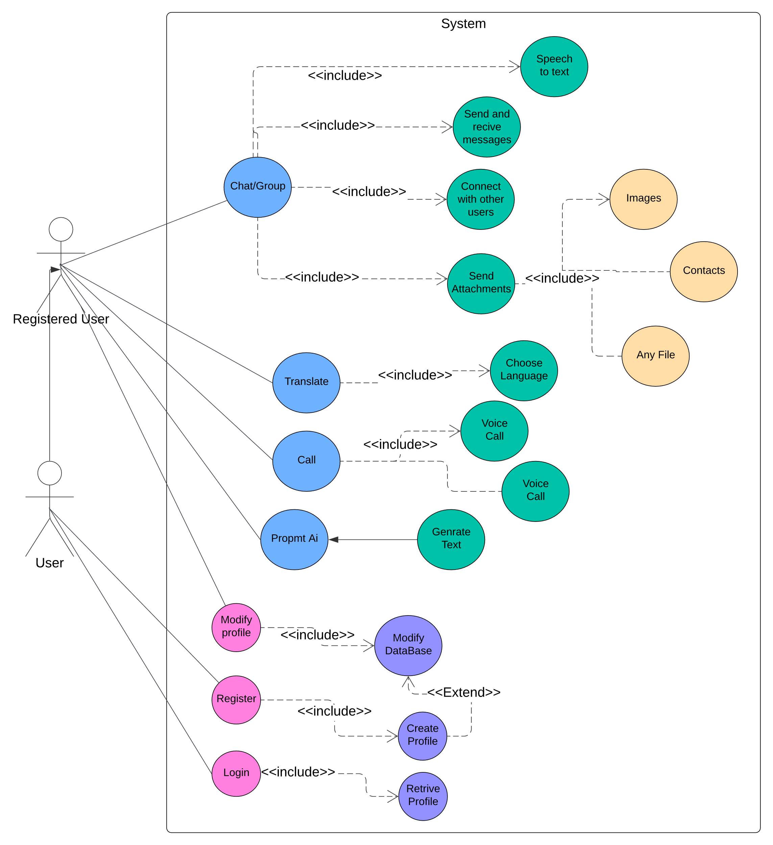

Figure 3‑1 Use Case Diagram

User Narrative Identification: Narrative identification of the use case for the Chat Application System is demonstrated in the table below.

|  |  |
| --- | --- |
| Use Case ID | 01 |
| Use Case Name | Register |
| Primary Actor(s) | New User |
| Secondary Actor(s) | None |
| Purpose | To allow new users to create an account. |
| Pre-condition | New users must input a valid phone number. |
| Post-condition | The new user profile is created in the database. |
| Events and steps | The user accesses the registration form to fill out registration details then he submits after that the credential Verification event starts and the profile is created in the database. |
| Exceptions | Registration form incomplete. / Wrong phone number format. |
| Additional Remarks | None |
| Conclusion | Regardless of location and time, any person can register and become a new user of the application. |

## System Architecture

The system will consist of multiple layers. Each layer is responsible for a specific aspect of the application functions. By using this approach, we ensure a modular and maintainable design.

The architecture comprises three primary layers: the Presentation layer, the logic layer, and the data layer. Each layer interacts with each other based on industry standards and protocols, ensuring a seamless and secure data flow throughout the system. The following section details the responsibilities of each layer.

**Presentation layer**: This layer is responsible for handling user interaction. It is implemented as an Android application that utilizes Java for core code and XML for layout design.

* UI Components: Activities, Fragments, and Views that handle input and data from the user.
* User Experience: Navigation and error handling.
* Communication With Server and APIs: Sending user requests and receiving responses for real-time updates.

**Logic layer**: this layer contains the core functionality and rules of the app. This layer handles user requests, performs necessary communications, and interacts with the database layer to retrieve essential information.

* Chat And Call Management: handling communication and ensuring message delivery.
* Translation: Providing language translation using APIs.
* Ai integration: using AI for generating text and images.
* Profile management: Handles user modifications and ensures consistent data display.

**Data Layer:** The **Data Layer** is responsible for storing and managing all persistent data required by the application.

* Database connectivity: Managed by Firebase real-time database.
* CRUD operations: Performed through firebase SDK’s.
* Query processing: Efficient execution of queries.

Figure 3‑2shows the system architecture and design.

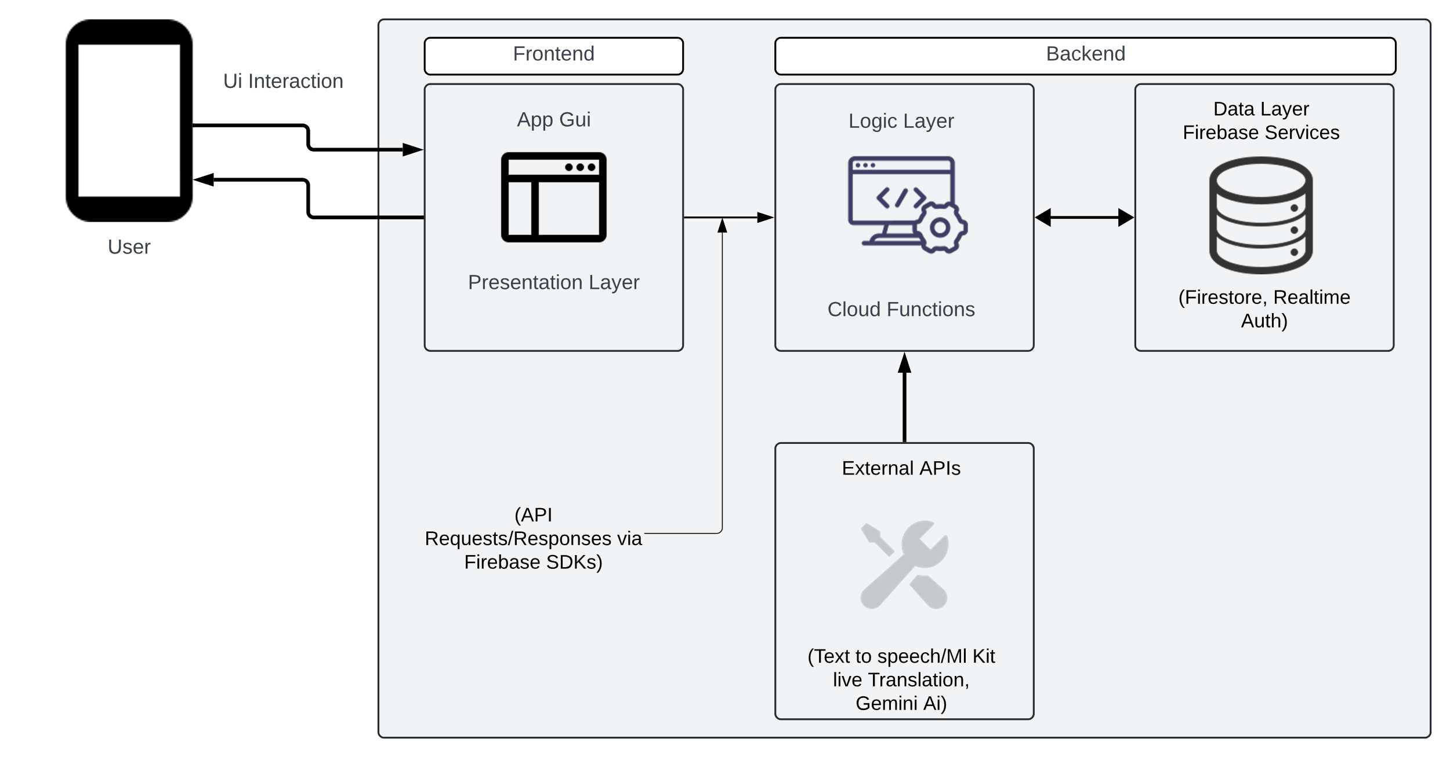

Figure 3‑2 System Architecture

**Diagram Explanation:**

* User: interacts with the app through the user interface.
* Android App (UI): The interface where the user interacts with the application. Uses Firebase SDKs to interact with Firebase services.
* **Presentation Layer**: Manages user interactions and sends/receives data from Firebase.
* Logic layer: Contains the core functionality and rules.
* Data Layer: Managed by Firebase, which includes:
* Fire store or real-time database: Stores structured data such as user profiles and chat history.
* Firebase Authentication: Manages user authentication and security.
* Firebase Storage: Manages file storage.
* Security Rules: Ensures data integrity and security.
* External APIs: Integration with external translation services, and AI-generated content.

**Workflow:**

The system workflow begins with the user interaction with the app. The app sends a request to Firebase using Firebase SDKs. Firebase processes the request, which may involve data access or the execution of a specific function such as translation. Firebase then sends a response to the Android app, which updates the user interface based on the response received.

## Class Diagrams

In this section, we are providing a UML class diagram that depicts the system's core structure. The diagram visually represents the relationships between the application's various elements or classes. By illustrating these relationships, the diagram demonstrates how the entities relay and interact with one another. Creating a class diagram is an important stage in system design because it provides a framework for implementing the project. It allows for a clear knowledge of the system's hierarchy and helps in the creation of an organized design before proceeding with the implementation phase. Figure 3‑3 Shows the Class Diagram.

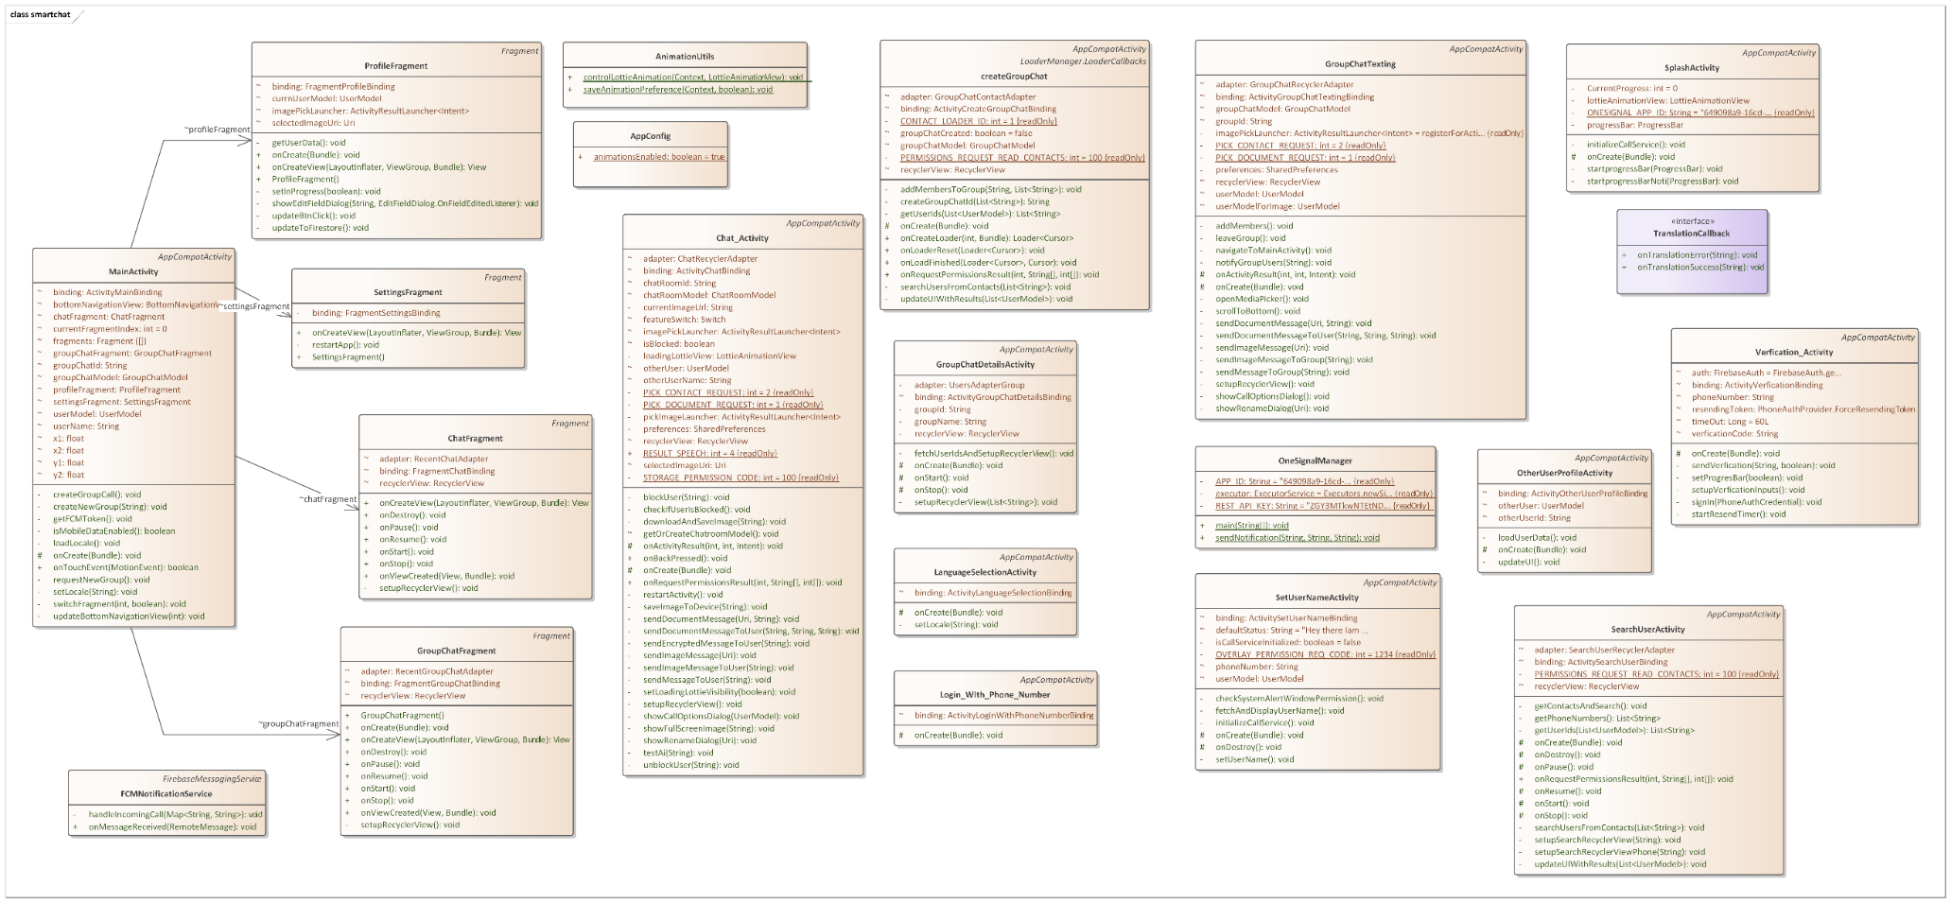

Figure 3‑3 Class Diagram

User:

* Attributes: userId, username, email, password, profilePicture.
* Methods: register(), login(), modifyProfile(), sendMessage(), receiveMessage()

Chat:

* Attributes: chatId, participants, messages
* Methods: sendMessage(), receiveMessage(), addParticipant(), removeParticipant()

Message:

* Attributes: messageId, senderId, receiverId, timestamp, content, attachments
* Methods: getContent(), setContent(), getTimestamp(), setTimestamp()

Translate:

* Attributes: originalText, translatedText, sourceLanguage, targetLanguage
* Methods: translateText(), chooseLanguage()

Call:

* Attributes: callId, callerId, receiverId, timestamp, callDuration
* Methods: startCall(), endCall(), getCallDetails()

PromptAI:

* Attributes: promptId, promptText, generatedText
* Methods: generateText()

Profile:

* Attributes: profileId, userId, bio, preferences
* Methods: createProfile(), modifyProfile(), retrieveProfile()

Database:

* Attributes: connectionString
* Methods: createProfile(), modifyProfile(), retrieveProfile(), storeMessage(), retrieveMessage().

Relationships:

* User has a one-to-many relationship with Chat.
* Chat has a one-to-many relationship with Message.
* User has a one-to-one relationship with Profile.
* Translate, Call, and Prompt AI interact with Users.
* Database is utilized by Profile, Chat, and Message.

## Sequence Diagrams

Sequence diagrams are UML diagrams that show how items in a system interact with one another by performing several operations. These diagrams can be interpreted as a form of collaboration among the systems classes. The sequence diagrams given in the figures below can help readers understand the flow of the application.

User Registration and Authentication: This graphic depicts the stages taken when a user registers or logs into an application. The Android app submits an authentication request to Firebase Authentication, which processes it and delivers an authentication token. The program then refreshes the user interface to reflect whether the authentication attempt succeeded or failed (Figure 3‑4).

Sending a Message with AI Translation: When a user sends a message that requires AI translation, it is sent to Firebase Cloud Functions via Firebase SDK, which then sends the message content to an external translation API, stores the translated message in Firebase Database, and updates the Android App UI (Figure 3‑5).

Receiving a Message: This diagram depicts the process of receiving a new message. The Firebase SDK listens for new messages in the Firebase database. When a new message is received, it retrieves the message data and modifies the Android App UI to present it to the user (Figure 3‑6).

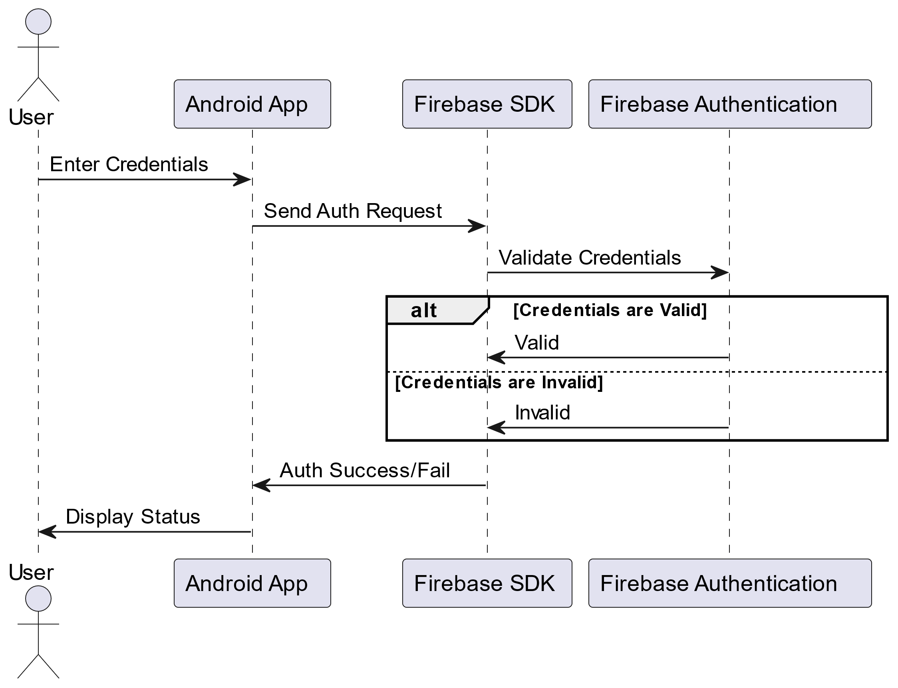

Figure 3‑4 User Registration and Authentication Sequence Diagram

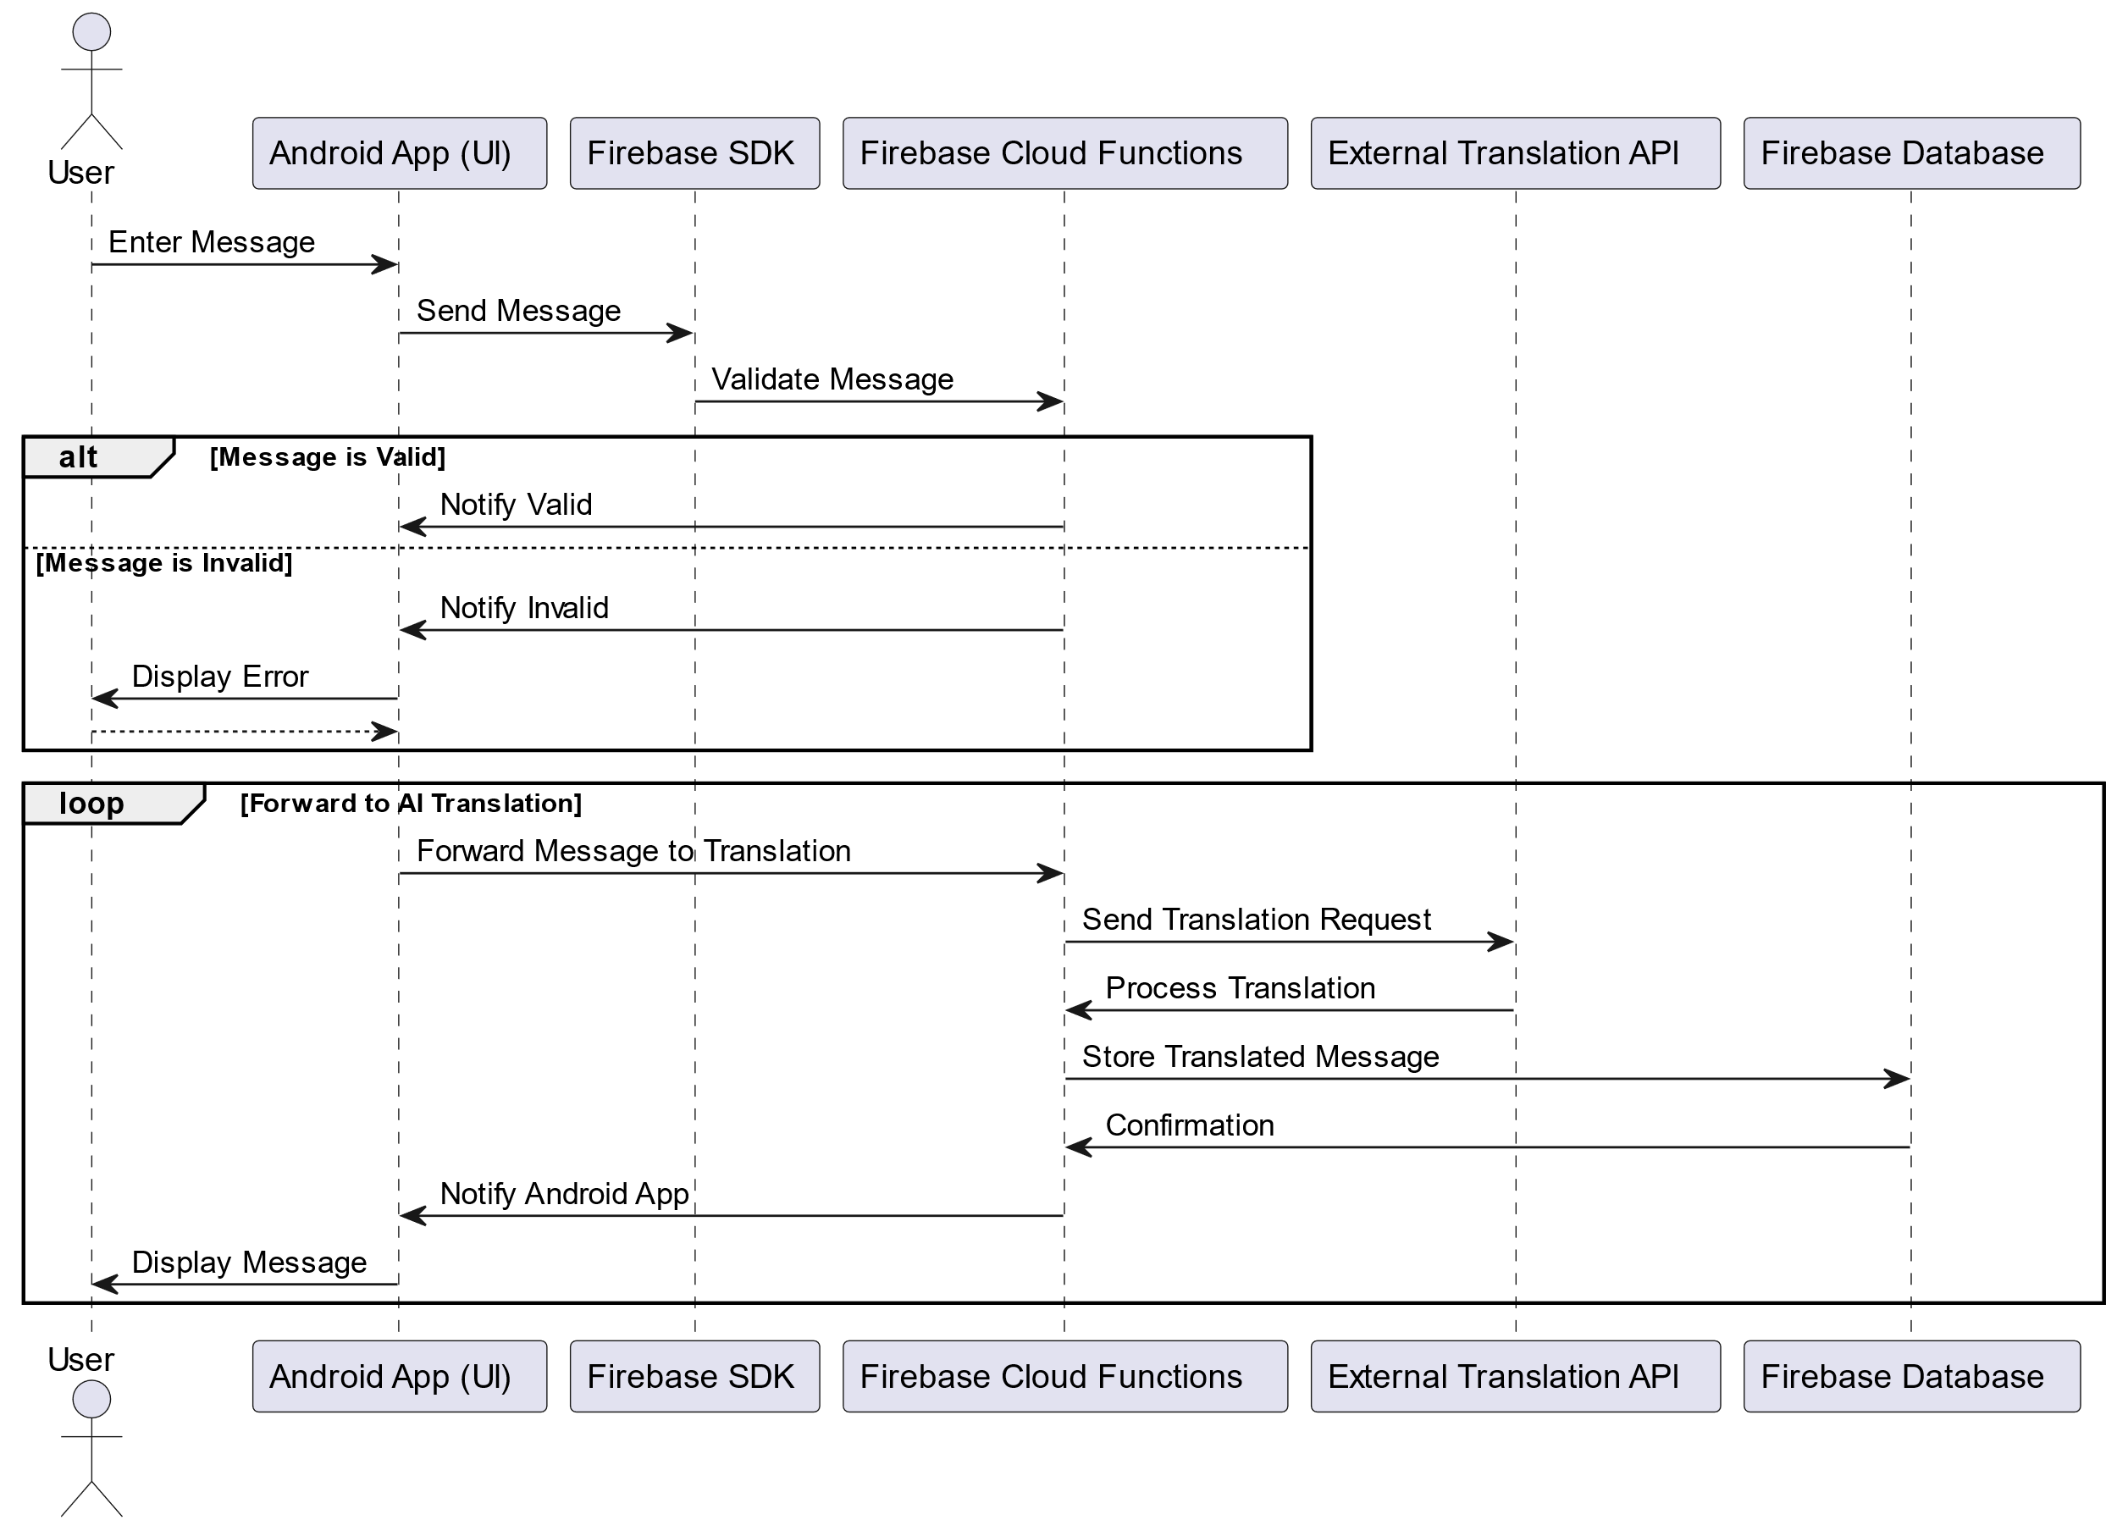

Figure 3‑5 Sending a Message with AI Translation Sequence Diagram

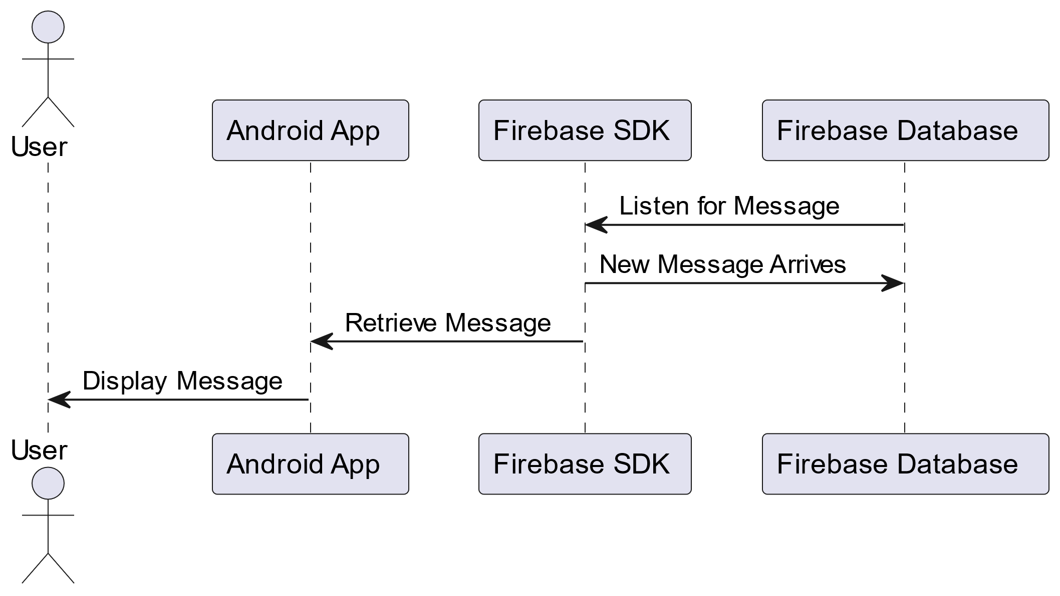

Figure 3‑6 Receiving a Message Sequence Diagram

## Activity Diagrams

The way activities and actions go through a system process is represented using activity diagrams, a type of Unified Modelling language. They display the decisions, actions, and control flows that take place when the program is being executed.

Activity Diagrams help the audience comprehend and evaluate the behavior of a system by providing a visual representation of intricate workflows or processes. Regular readers will find it easier to understand each system user's principal application scenarios with the aid of the activity diagrams shown in the illustrations below.

Figure 3‑7 shows the user registration procedure. A user accesses the registration page and enters their information to start the process. A verification code is sent and the data is kept in a Firebase database if it is valid. Registration is finished after the code verification is successful. The user is instructed to fix the problem if any step fails and the relevant error messages are displayed.

In Figure 3‑8, the flowchart illustrates the login process. Users begin by entering their credentials on the login screen. The system verifies the user's identity using Firebase Authentication if these details are correct. Upon successful authentication, the user's profile is retrieved and granted access to the main application page. An error message is displayed if the credentials are incorrect, prompting the user to try again.

Figure 3‑9 illustrates the process of sending and translating a message within a chat application. The user starts by opening the chat page and entering a message. If the message is valid, it is sent to a Firebase database and an AI translation service is invoked to translate the message. The translated message is then displayed to the user. If the message is invalid, an error message is shown.

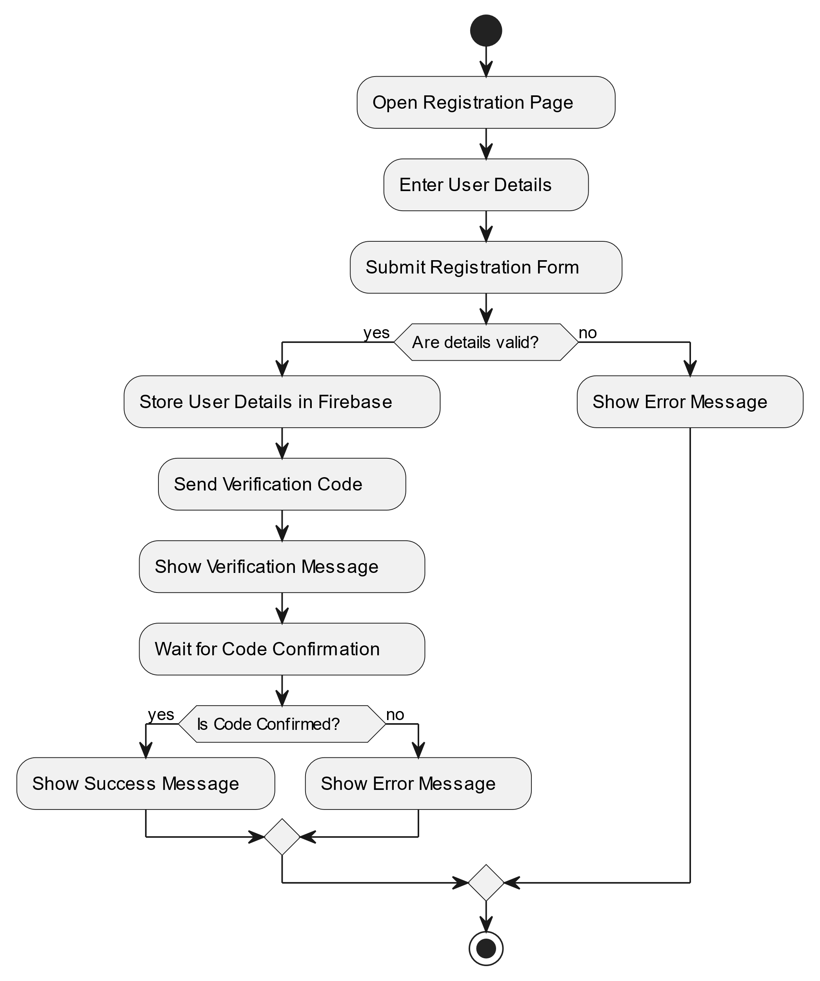

Figure 3‑7 User Registration Activity Diagram

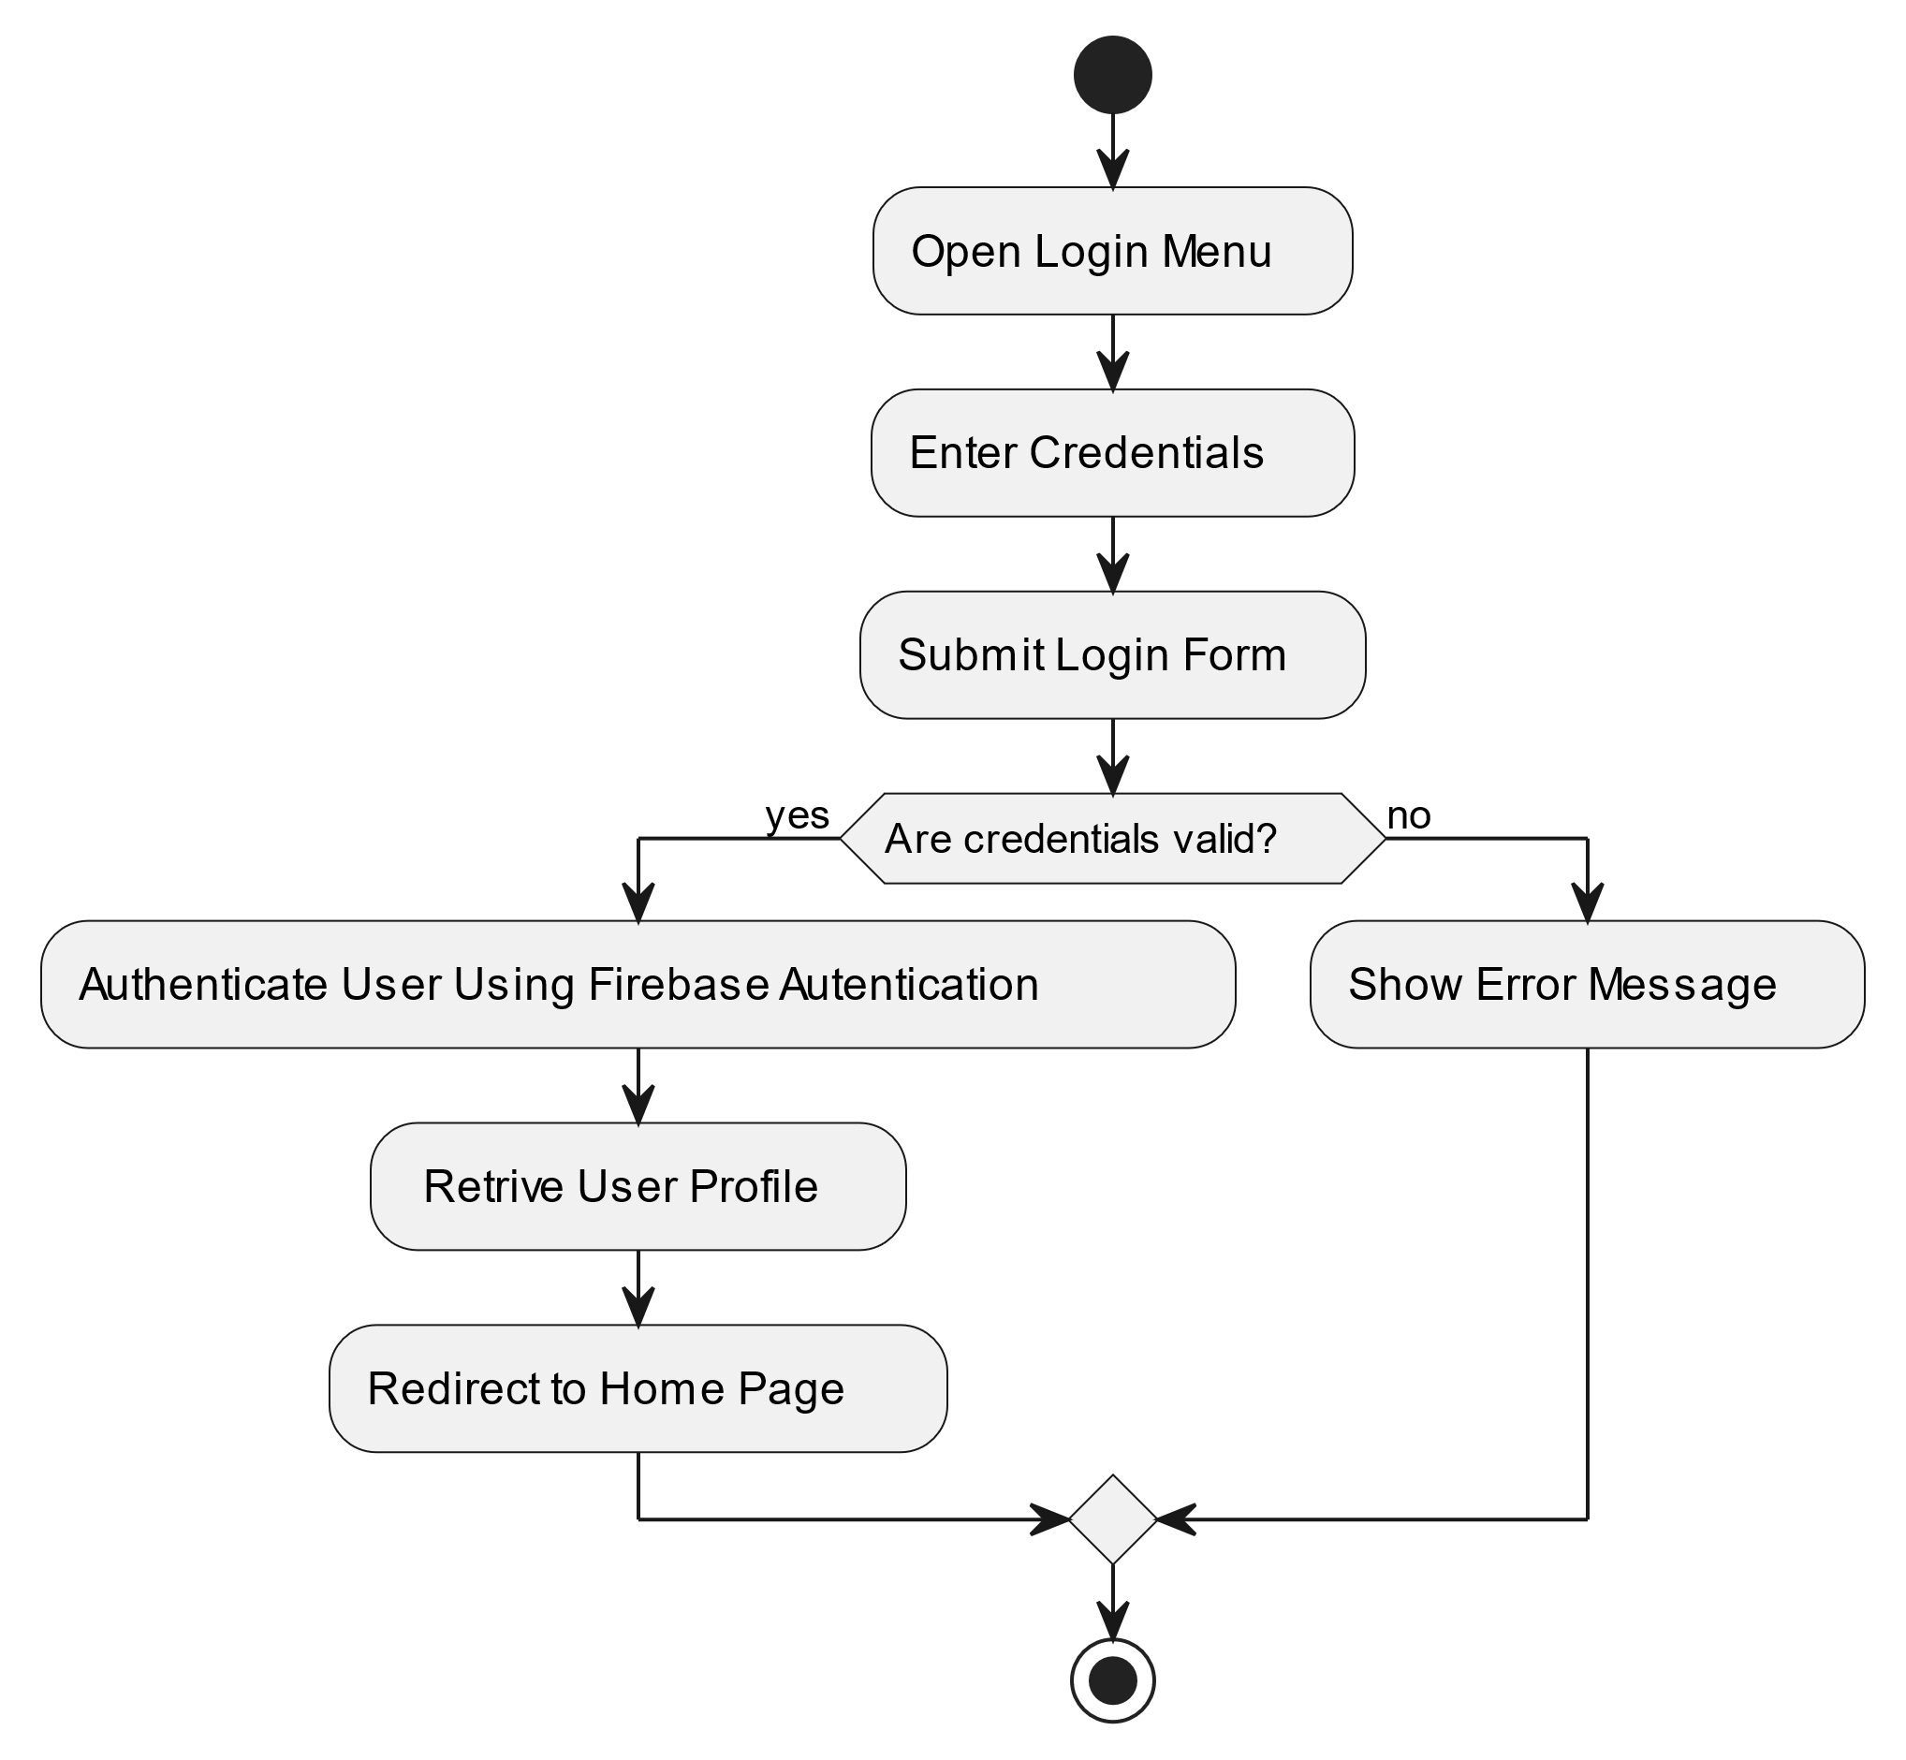

Figure 3‑8 User Login Activity Diagram

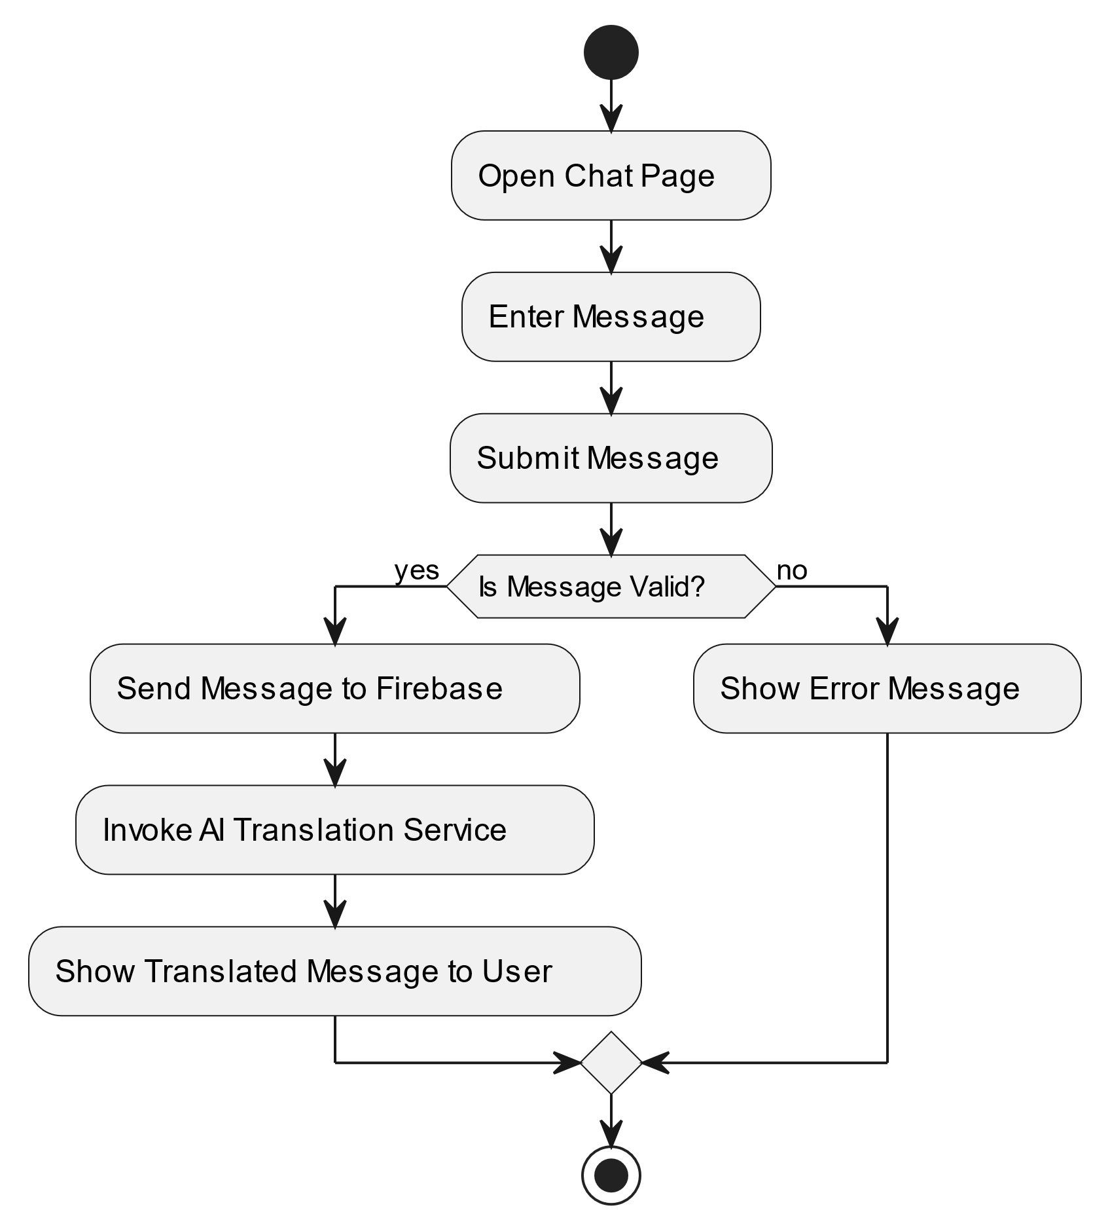

Figure 3‑9 Sending a Message with AI Translation Activity Diagram

## Entity-Relationship (ER) Diagrams

An entity relationship diagram (ERD) is a graphical representation of entities and their relations to each other.

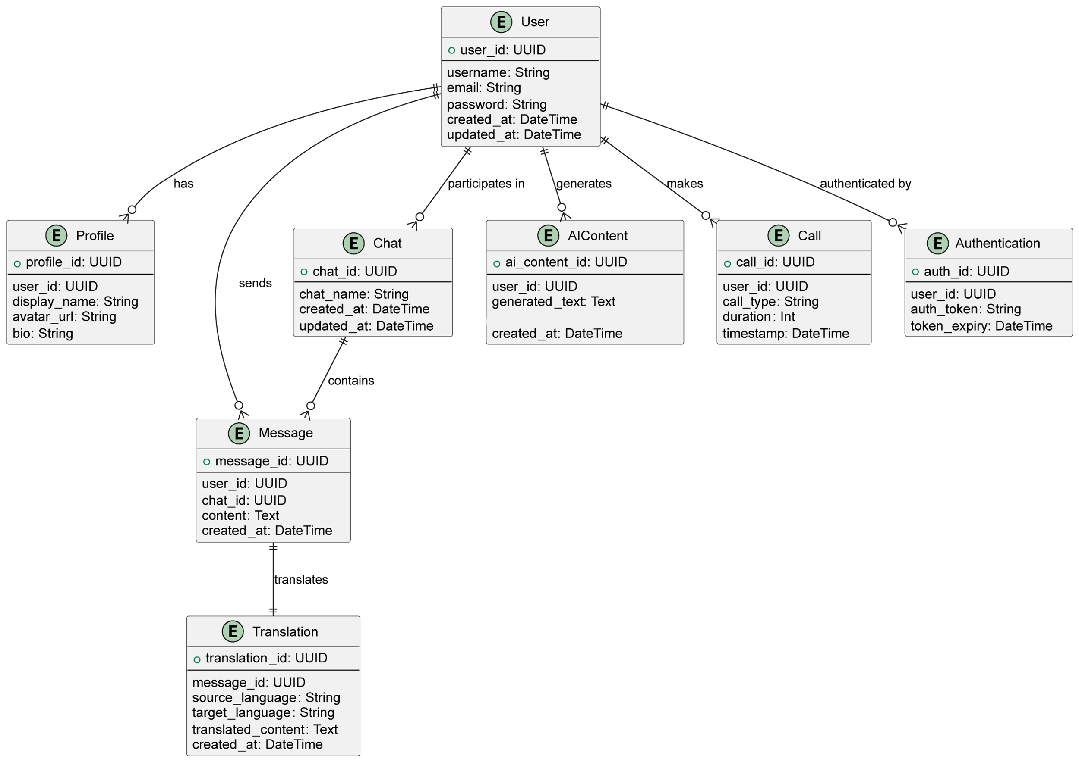

Figure 3‑10 Entity-Relationship Diagram

**User**: Represents a user in the system.

* Attributes: user_id, username, email, password, created_at, updated_at

**Profile**: Represents the user's profile.

* Attributes: profile_id, user_id, display_name, avatar_url, bio
* Relationships: Each User has one Profile.

**Message**: Represents a chat message.

* Attributes: message_id, user_id, chat_id, content, created_at
* Relationships: Each Message is sent by one User and is part of one Chat.

**Chat**: Represents a chat or conversation.

* Attributes: chat_id, chat_name, created_at, updated_at
* Relationships: Each Chat contains multiple Messages and involves multiple Users.

**Translation**: Represents a translated message.

* Attributes: translation_id, message_id, source_language, target_language, translated_content, created_at
* Relationships: Each Translation is linked to one Message.

**Authentication**: Represents the authentication information for a user.

* Attributes: auth_id, user_id, auth_token, token_expiry
* Relationships: Each User can have multiple Authentication records for different sessions.

**AI Content**: Represents AI-generated content such as text and images.

* Attributes: ai_content_id, user_id, generated_text, created_at
* Relationships: Each AIContent is generated by one User.

**Call**: Represents a call made by a user.

* Attributes: call_id, user_id, call_type (voice or video), duration, timestamp
* Relationships: Each Call is made by one User.

## Non-Technical Aspects

### Financial Viability

The Mart Chat Application is a financially promising Endeavor. Since the project is software-based, no costly hardware is needed, which drastically lowers the total cost of development. Furthermore, the main expenses are related to the use of cloud services and APIs; both are scalable by consumption, making cost management effective.

A cost-benefit analysis has been carried out to assess the Smart Chat Application's possible financial sustainability (as stated in the table below). The OpenAI API and Firebase services, which are necessary for the operation of the app, are the subject of the investigation along with their yearly costs. While not immediately measurable in this table, the advantages come from better user experience, more engagement, and improved functionality, all of which are anticipated to promote user preservation and attraction.

|  |  |
| --- | --- |
| Benefits | Costs |
| |  | | --- | | Improved User Experience |  |  | | --- | |  | | Google Gemini API |
| |  | | --- | | Increased Engagement |  |  | | --- | |  | | Firebase Services |
| |  | | --- | | Enhanced Functionality |  |  | | --- | |  | | Releasing the app on Google Play |
| The costs scale with user numbers. | |

Table 2‑1 Cost Benefit Analysis

### Stakeholders

A stakeholder is any person who could have an interest in a particular project, organization, or system. Stakeholders for the Smart Chat app include individuals in need of seamless communication that protects their privacy and data, non-native speakers, and those with grammar challenges benefiting from auto-correction and translation features. The Smart Chat app provides an easy-to-use platform for communication with AI services. This is helpful for individuals who struggle with grammar and spelling issues as auto-correction helps correct spelling and grammatical mistakes, making the communication clearer and more professional. This can help the user gain confidence in his writing abilities and help to save time and effort in editing messages, allowing users to communicate more efficiently. Individuals who communicate in different languages and need to understand and interact with users who speak other languages also benefit from the app. Translation feature enables users to communicate effectively with others who speak different languages by automatically translating messages to the user language. This promotes better understanding and cultural exchange, allowing users to share and learn from different perspectives. In addition, people who might not know how to write effectively but have ideas they want to express can benefit from an AI-powered prompt that generates text. While the Smart Chat app has the potential to benefit many stakeholders, some may be negatively impacted by its implementation. The existing chatting app is due to the additional features in the app, which can affect them. In addition, freelance translators are going to be affected due to the app’s AI-driven translation. It is important to recognize and address these potential harms to ensure that the app is developed fairly for all stakeholders.

To ensure the Smart Chat app is designed to address the needs and interests of all stakeholders effectively, it is crucial to include different perspectives in the implementation phases. Several groups should have a say in how the project works:

* Users: Users of the Smart Chat app are a crucial stakeholder group, as they will be the ones using the app for communication, translation, and auto-correction services. Gathering feedback from users throughout the development process is essential to ensure the app meets their needs and expectations.
* Existing chatting apps: As mentioned earlier, existing chatting apps may be negatively impacted by the implementation of the app. It is important to engage with these companies to understand their concerns and work with them.

### Scope

The Smart Chat application project is designed to enhance communication between users through artificial intelligence. The app will allow users to chat by sending text messages, audio voices, and attachments, and by making voice calls. In addition, the app will contain an AI prompt that will help the user by generating photos or texts, which is so helpful for people who do not know how to express what they want to say in an organized way. Moreover, people with spelling mistakes will benefit from the auto-correction available. In addition, users who want to talk to others but have the language as a barrier will benefit from the auto-translation feature where each user chooses a preferred language and any text sent to him will be translated to the preferred language.

However, only Arabic, English, and French are available for translation and there is no page for sharing posts or status.

### Risks

One of the significant risks of the app is the lack of trust from users on the app due to privacy and security reasons. This could be due to the news and negative reviews of different apps that sell the data of their users. Data security and privacy represent a critical risk, given that the application will handle sensitive personal information, including private messages between users. To avoid this risk, it is crucial to provide users with clear privacy policies.

Another risk is the quality and accuracy of the AI features. The auto-correction and translation feature may not meet the user's expectations, which can lead to miscommunications or incorrect translations. Similarly, the AI-generated text might not always be as user needs or preferences. This could result in user frustration and negative feedback. To address this risk, it is essential to continually update the AI models based on user feedback and performance data.

Another critical risk is that the app must operate with high performance and efficiency to provide the user with a good experience. The app should remain fast and responsive under various conditions. Slow load times, lagging interactions, or unresponsive features especially when using AI, and how much time will it take for translation, all of this can affect app performance. To address this risk, the application must be developed with efficient code to try to avoid the above problems.

### Schedule and Milestones

The schedule and milestones of the project depict the many tasks that will be done in this system, along with their time length.

|  |  |  |  |
| --- | --- | --- | --- |
| **Task Name** | **Start** | **Finish** | **Weeks** |
| Defining the Project | July 2 | July 4 | 1 |
| Pre-Development | | | |
| Project Overview | July 5 | July 7 | 2 |
| Initial Draft | July 8 | July 9 | 2 |
| Designing UML Diagram | July 10 | July 18 | 3 |
| Pre-Development | | | |
| Setting up the  database | July 19 | July 23 | 4 |
| Research how to use AI. | July 24 | July 30 | 5 |
| Development | | | |
| Application Development | July 31 | September 15 | 6-9 |
| Post-Development | | | |
| Testing and final changes | September 16 | September 20 | 10 |

Table 2‑2 Scheduling Tasks and Milestones

### Ethical and Social Consideration

When developing the Smart Chat app with integrated AI features, several crucial ethical and social considerations must be carefully addressed to ensure the best experience for the user. One of the main things that should be taken into consideration is the privacy and data security of the user. The app should use strong protections to keep user information safe, including encryption to secure data both when it is sent and stored. It is important to collect only the data needed for the app’s function and to let users know what data is collected and how it is used. Another key issue is how AI is used. The app should ensure the accuracy and reliability of AI features, especially in translation where any mistake can lead to problems with users because of misunderstanding. By addressing these ethical and social considerations, the Smart Hat app can build trust, encourage positive interactions, and ensure responsible use of AI technology.

### Environmental and Sustainability Considerations

This project does not endanger or affect the environment.

### Relevant Standards

1. Mobile Application Testing and Verification (IEEE 829): This standard provides guidelines for testing and verifying mobile applications, including functional performance testing, and security testing.

2. Wi-Fi: based on the IEEE 802.11 standard, is a wireless network technology that connects devices to the internet via a wireless router.

3. Firebase Database Rules: Firebase provides specific rules for accessing and managing data securely in real-time databases, ensuring data integrity and security.

4. OpenAI Specification: A standard for defining APIs, allowing for consistent and comprehensive documentation of API functionalities.

5. JSON: This is a standard data exchange format that uses human-readable language to store and transport data objects as attribute-value pairs and arrays.

## Conclusion

To summarize, the development of the Smart Chat app with AI features represents a significant step in enhancing communication through advanced technology. The design phase of the chat app project has been thoroughly planned and analyzed in this report. The MVC structure of this system offers some organization while also making it lighter and faster to develop. The diagrams in this chapter describe what this system intends to do and how it intends to accomplish it based on its design, breaking each component down into simple images for both technical and non-technical audiences. The non-technical aspects, such as financial viability, stakeholders, scope, risks, schedule and milestones, and ethical and social considerations were considered to ensure the success and sustainability of the platform. However, it will be essential to monitor the app's performance closely, address any emerging challenges, and make necessary adjustments to optimize functionality.

# Implementation/Simulation and Testing

## Introduction

In this chapter, we will go through the Smart Chat System’s implementation phase. It will provide an overview of the tools used to achieve the system's final functionality, along with a detailed description of how the backend and frontend components were developed and integrated to build the app. In addition, it will describe the backend and frontend of the application, and highlight the steps taken to ensure seamless integration between these components. This chapter will shed light on the implementation journey of the Smart Chat application, from development to finish.

## Implementation Tools

* Languages:

We settled on Java and XML to be our main languages for implementing the project, and that is due to:

1. **Familiarity**: Because our team is experienced in these languages, we can effectively design the application using our current knowledge and expertise. Because of this familiarity, the development process runs more smoothly and the learning curve is lowered, enabling us to deliver a high-quality product on schedule.
2. **Platform Suitability**: Java was chosen to develop the Smart Chat app as it is a widely adopted programming language for Android app development, making it ideal for building a robust Android-based chat application. XML defines the app’s user interface, providing a structured and efficient way to manage layouts and UI components. For data storage, Firebase was selected as the backend due to its real-time database capabilities, seamless integration with Android, and scalability, ensuring efficient storage and retrieval of user data and chat messages.
3. **Ecosystem and Libraries**: Java, XML, and Firebase have strong ecosystems with rich libraries, frameworks, and tools that streamline the development process. The extensive resources, including Firebase SDKs and Java libraries, allow us to implement complex features such as authentication, real-time messaging, and file storage with ease. The vast documentation and community support accelerate the development process and ensure the app is built with reliable and well-supported technologies.
4. **Industry Standards**: Java, XML, and Firebase are recognized industry standards for Android development and mobile backend solutions. These technologies are used in many successful mobile applications, ensuring their long-term support and stability. The large developer community around Firebase and Java guarantees continuous improvements, best practices, and troubleshooting support, making them a reliable choice for building our Smart Chat application.

In summary, Java was chosen for Android app development, XML for UI design, and Firebase for backend and database management. These technologies align with industry standards and provide a solid foundation for delivering a high quality, scalable and feature-rich chat application.

Application Design:

* Lottie Files: Lottie Files was used for icon design and animations in Smart Chat. This platform allows for dynamic animations that enhance user engagement, adding visual appeal to the app. Lottie Files offers scalable, lightweight animations that help streamline the design process, ensuring the app remains visually engaging and interactive.
* UI/UX: Design is essential for Smart Chat as it directly impacts usability, user engagement, and branding. A well-crafted UI/UX enhances user satisfaction by making the app intuitive and easy to navigate. It reduces errors, improves efficiency, and fosters user loyalty by creating a seamless experience.

Database:

* Firebase: Firebase is the main database used in Smart Chat. It provides real-time data synchronization, efficient storage, and easy retrieval of user and chat data. The cloud-based system also supports secure authentication and scaling, making it an ideal solution for handling the app’s backend needs.

Android Studio:

* IDE: Android Studio was the integrated development environment (IDE) of choice for building Smart Chat. It offers fast and powerful tools to develop Android apps, including intelligent code editing, real-time UI previews on multiple devices, and a flexible build system. These features allowed us to design and test the app efficiently across different Android devices. The built-in API and device pairing tools helped ensure the app’s responsiveness and functionality across various devices and screen sizes.

## Implementation Summary

In this section, we will explore the implementation of the Smart Chat app, presenting its design and core functionalities. The implementation of the app is based on a simplified architecture that leverages Firebase for both the backend and database, as discussed earlier in Section 3.6, which focuses on the system’s design and architecture.

The front-end layer of the app is designed for users to interact seamlessly with Smart Chat's messaging, authentication, and storage features. Unlike traditional apps that include an admin-side component, Smart Chat automates much of the data management through Firebase, ensuring that data is securely stored and encrypted without the need for manual oversight.

During development, the Model-View-Controller (MVC) pattern was used to ensure a clear separation of concerns. The Model manages data and business logic, the View (UI) presents information to users and captures their input, and the Controller (adapters) handles the communication between the Model and the View. This pattern helps maintain modularity and reusability throughout the app.

The app's Java classes are organized into packages to maintain a clean and scalable structure. These include utility classes for common functions, fragments for reusable UI components, and storage management for uploading and downloading images or documents. Firebase handles authentication, real-time messaging, and cloud storage, eliminating the need for a traditional server infrastructure. Figure 4‑1 shows the MVC layout configuration.

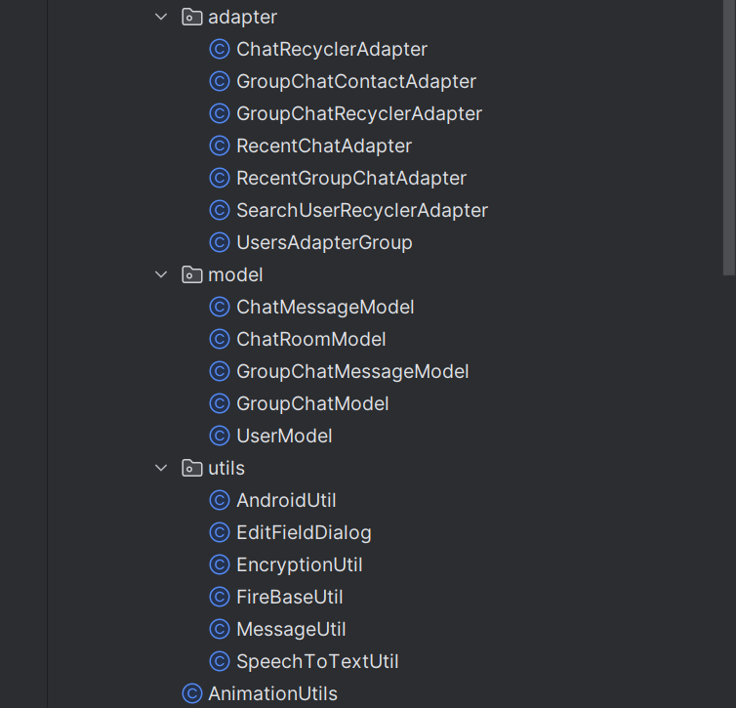

Figure 4‑1 Model-View-Controller Design.

By employing this architecture, patterns, and organized package structure, the implementation of the Smart Chat app achieves a clean, modular, and maintainable codebase. This design promotes code reusability and scalability while ensuring secure data management through Firebase.

Firebase:

For managing user information, Firebase was chosen as the database and backend system. System Architecture details the architecture and entity relationships in the Smart Chat app, focusing on how Firebase efficiently stores and syncs user data. By utilizing Firebase’s real-time database, Smart Chat ensures seamless data management.

Firestore:

* **Reads:** the app interacts with Firestore to retrieve data, such as messages, user profiles, or group chat details, refer to Figure 4‑2.
* **Writes:** Writing to Firestore occurs when data is sent or updated, like sending a message, updating profile information, or creating a new chatroom.

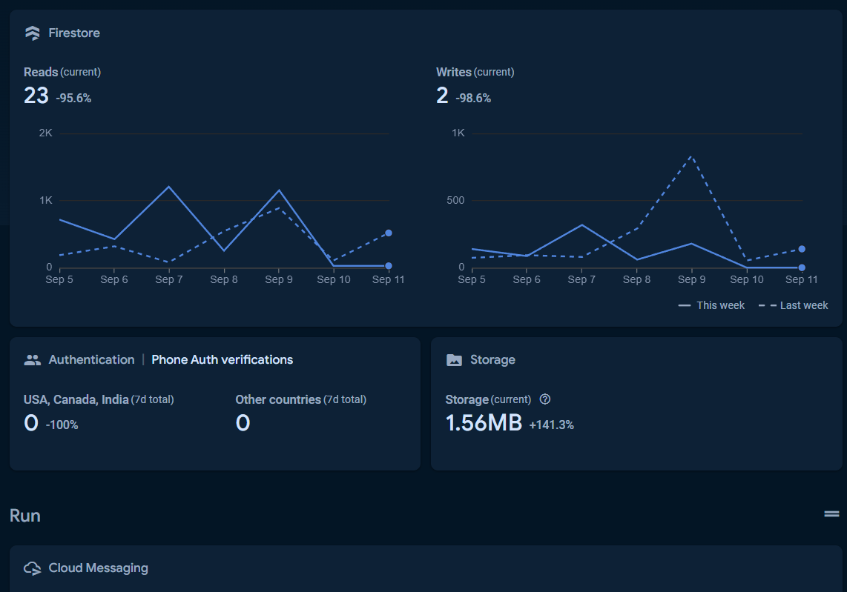

Figure 4‑2 Overview of Firebase Services for Smart Chat App

Authentication:

* **Phone Auth Verifications:** Firebase Authentication uses phone numbers as part of the app's user sign-up and login flow. When a user enters their phone number, Firebase sends them an OTP for verification. This service helps ensure that only verified users can access the app.

Storage:

* **Storage Usage:** Firebase Storage is used to store media files such as images and documents that users upload within the app. Figure 4‑3goes into detail on what each section contains.

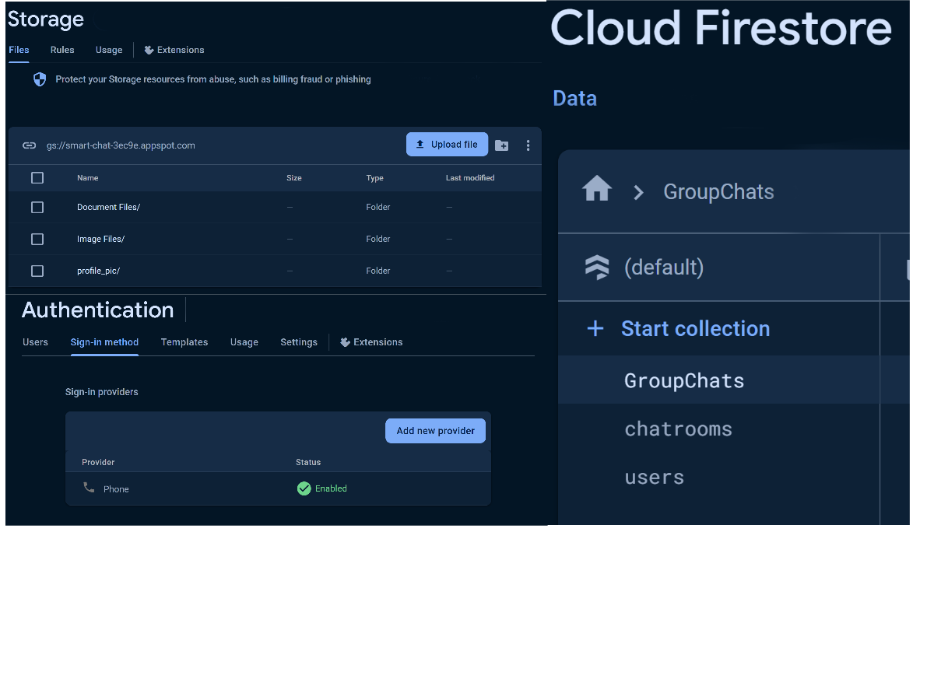

Figure 4‑3 Detailed Overview of Firebase Services for Smart Chat App

Next, we will discuss the **Activities** within the app, which apply to all user types, including the sign-in/log-in process, message handling, media uploads, real-time chat functionalities, and settings.

Login and Sign-up Processes:

The user's experience within the Smart Chat app begins with a straightforward login process consisting of three key steps (Figure 4‑4). First, the user is asked to input their phone number, and then they receive and enter an OTP verification code. If the OTP doesn’t arrive within 60 seconds, there’s an option to resend the code. After successful verification, the user proceeds to create a username, finalizing the registration.

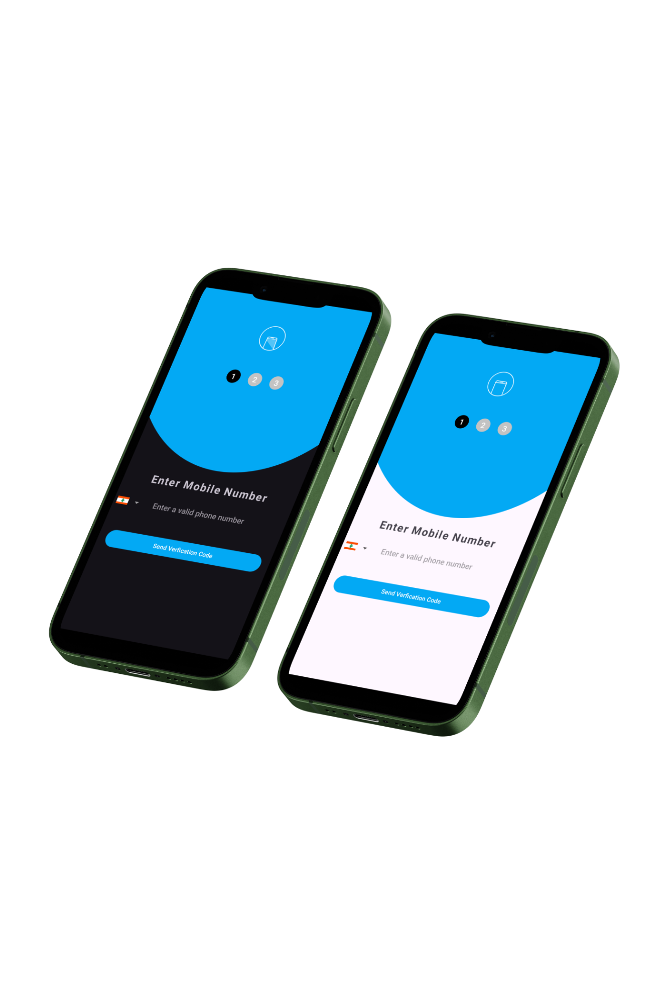

Figure 4‑4 Registration views for Smart Chat Dark/light themes

For existing users, the login process mirrors the sign-up. Upon entering their phone number, their previous username is automatically retrieved, with the option to modify it if desired. This efficient process ensures swift access to the app’s features and services. Figure 4‑5 displays the process of logging in/ signing up.

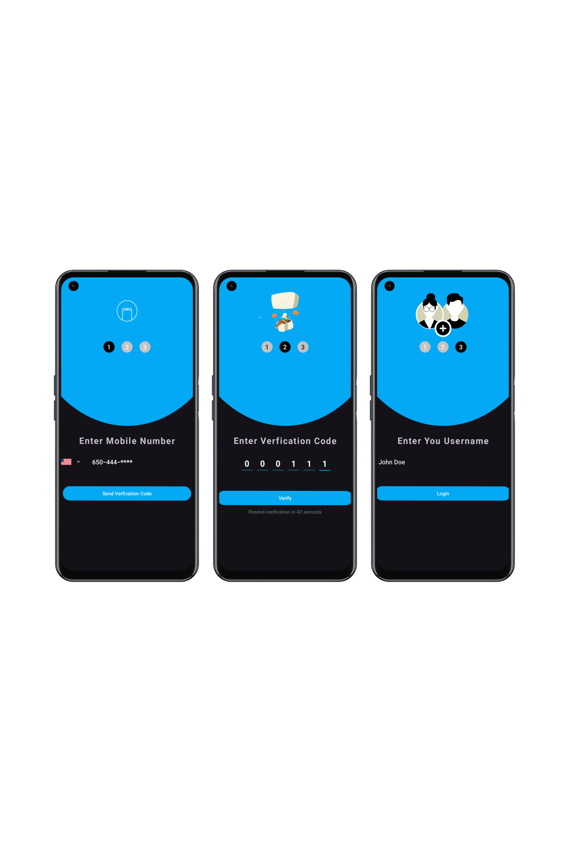

Figure 4‑5 Step-by-step representation

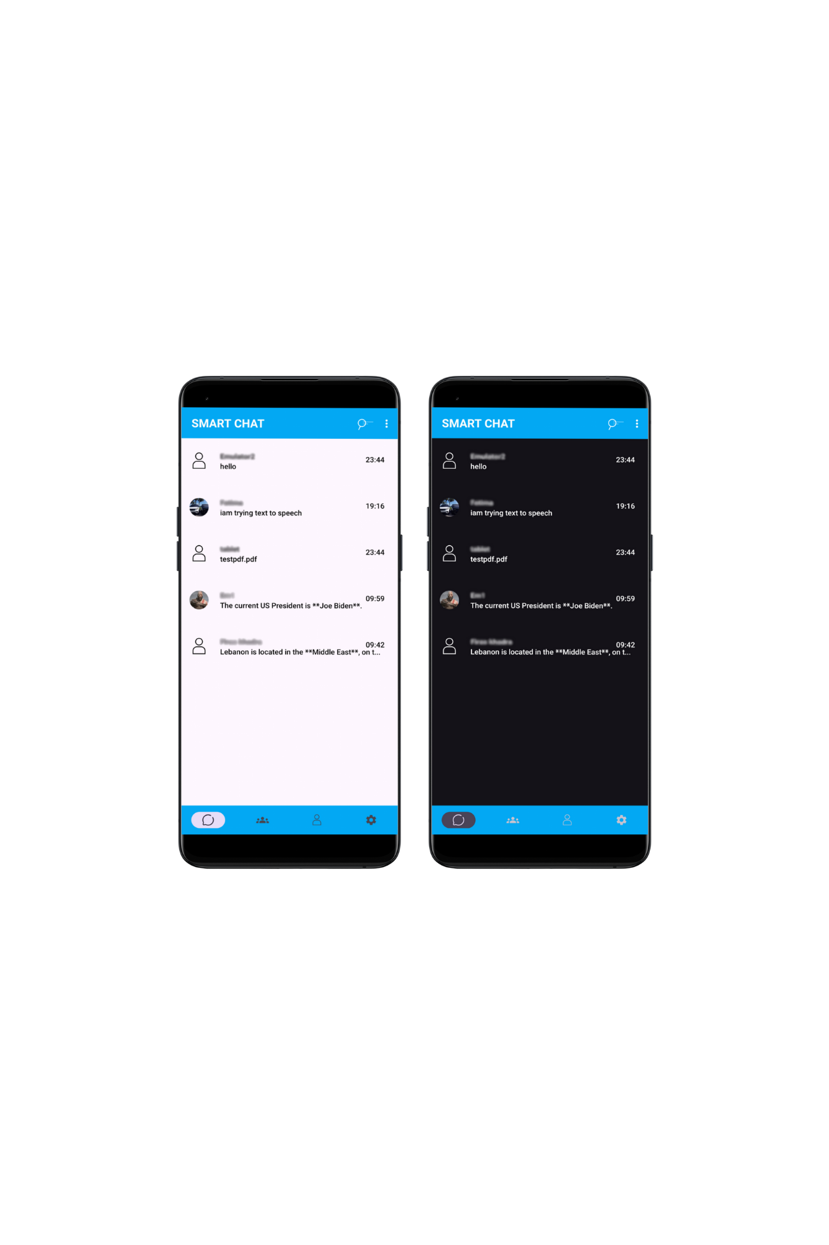

Figure 4‑6 Home Page

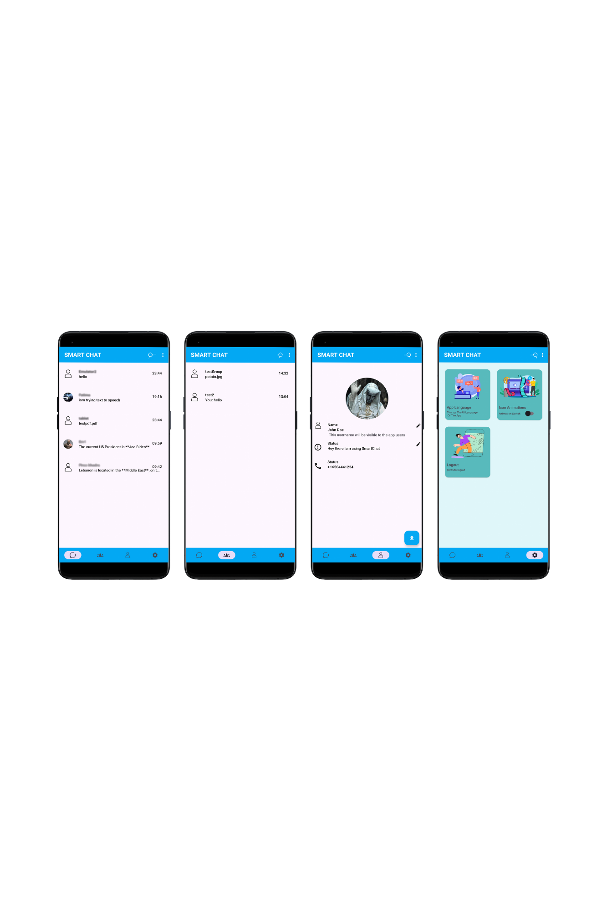

Figure 4‑7 Chats, Groups, Profile, Settings Views.

The home page of the Smart Chat app serves as the central hub for navigating through its key features. At the bottom navigation bar, users can access their Chats, where they can view, create, and manage one-on-one conversations with other users. The Group Chats section allows users to join or create group conversations, making it easy to communicate with multiple contacts at once. In the Profile section, users can view and edit their personal information, such as username, status, and profile picture. The Settings menu provides access to various customization options, including language preferences, logout settings, and app animation options. This intuitive layout offers users seamless navigation and full control over their messaging experience within the app.

Search Activity and Creating One-To-One:

Chatroom:

In the Smart Chat app, creating a chatroom with another user can be done easily through the Search Activity. Users have two options to initiate a chat: they can either search for a specific user by entering a username or phone number in the search bar, or they can click the Contacts button to view a list of app users who are already saved in their phone contacts (Figure 4‑8). Once the desired user is located, clicking on their name will automatically create a one-on-one chatroom.

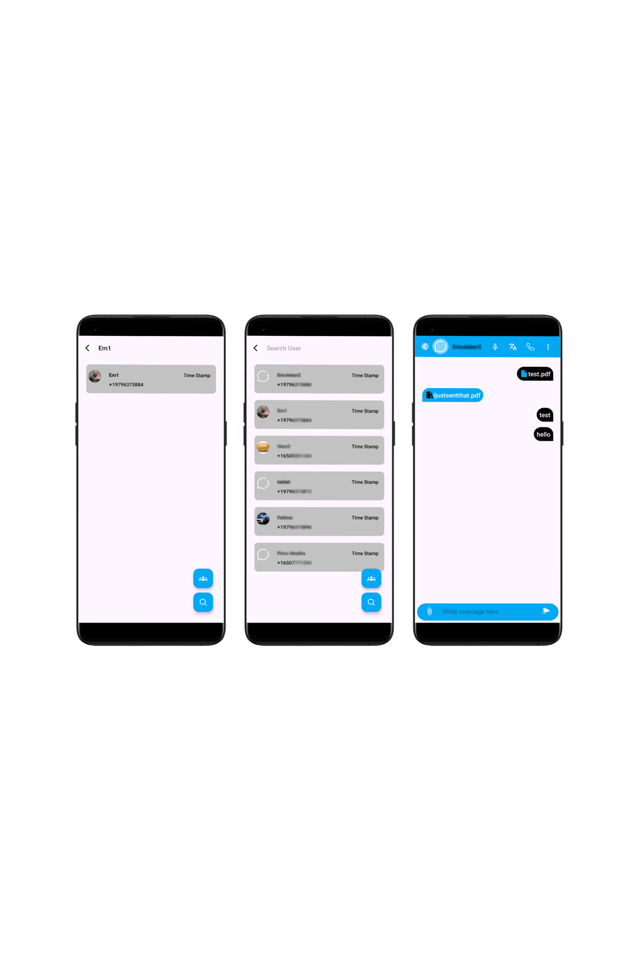

Figure 4‑8 Selecting a user from Search Activity

Behind the scenes, Firebase generates a unique chatroom ID based on the user IDs of both participants which is assigned to them at signup by Firebase. This chatroom ID ensures that messages between the two users are stored and organized efficiently. After the chatroom is created, the users can send messages to each other seamlessly, making the process of starting conversations intuitive and fast.

One-To-One Chat Activity and its features:

The Chat Activity in the Smart Chat app is packed with a variety of features that make conversations interactive and versatile. Users can send regular text messages and also have the option to translate incoming messages into their desired language. This translation feature allows real-time translation for smooth communication across different languages.

Figure 4‑9shows chat activity and sending text messages.

The translation feature, enabled through Google ML Kit, permits users to select a target language and incoming messages are automatically detected and translated to the chosen language with high accuracy. This ensures that language barriers do not hinder communication, making Smart Chat a highly inclusive platform for users worldwide. Figure 4‑10 offers a showcase of this feature.

In addition to text messages, users can send images either by capturing photos with the camera or selecting them from the gallery. Documents and contacts can also be shared directly within the chat, with the files uploaded to Firebase Storage and linked to the chatroom, ensuring both participants can access them. Figure 4‑11 Walkthrough of sending an image, Figure 4‑12 sending a contact/document process.

In **Smart Chat**, when a user blocks a contact, all communication between the two parties is immediately restricted. The user who initiated the block will no longer be able to send messages to the blocked contact, and any previous conversation will be halted. On the other end, the blocked user will receive a notification informing them that they have been blocked. This will prevent them from sending messages. Figure 4‑13 presents what happens when you block a contact.

Users can also make voice or video calls using the Zego Cloud API. When a call is initiated, Zego connects both users using their Firebase IDs to establish a private channel. This seamless integration allows for high-quality voice and video interactions. Figure 4‑14 describes how a user initiates a video/audio call.

For accessibility, the app includes a Speech-to-text feature, allowing users to convert spoken words into text. This is especially useful when the user cannot type on the keyboard. Figure 4‑15 shows how to use speech-to-text.

A unique feature of Smart Chat is its AI integration with Google Gemini AI. By typing **/prompt** followed by a question or query, the user can interact with the AI, which will generate a response and paste it directly into the chat for the user to review and send. Figure 4‑16 shows how to prompt the AI.

In Smart Chat, security and confidentiality are top priorities. Every message sent between users is encrypted before being uploaded to Firebase. This ensures that the content remains secure and private, preventing unauthorized access. The encryption process adds a layer of protection, ensuring that only the intended recipient can decrypt and read the message, fostering a safe communication environment between users. Encryption will be further discussed later.

In terms of notifications, Smart Chat integrates with One Signal API to handle real-time message alerts. When one user sends a message while the other user is offline, a push notification is sent to the recipient's phone. The notification contains a preview of the message and indicates the sender, making it easier for the recipient to stay updated even when they are not actively using the app.

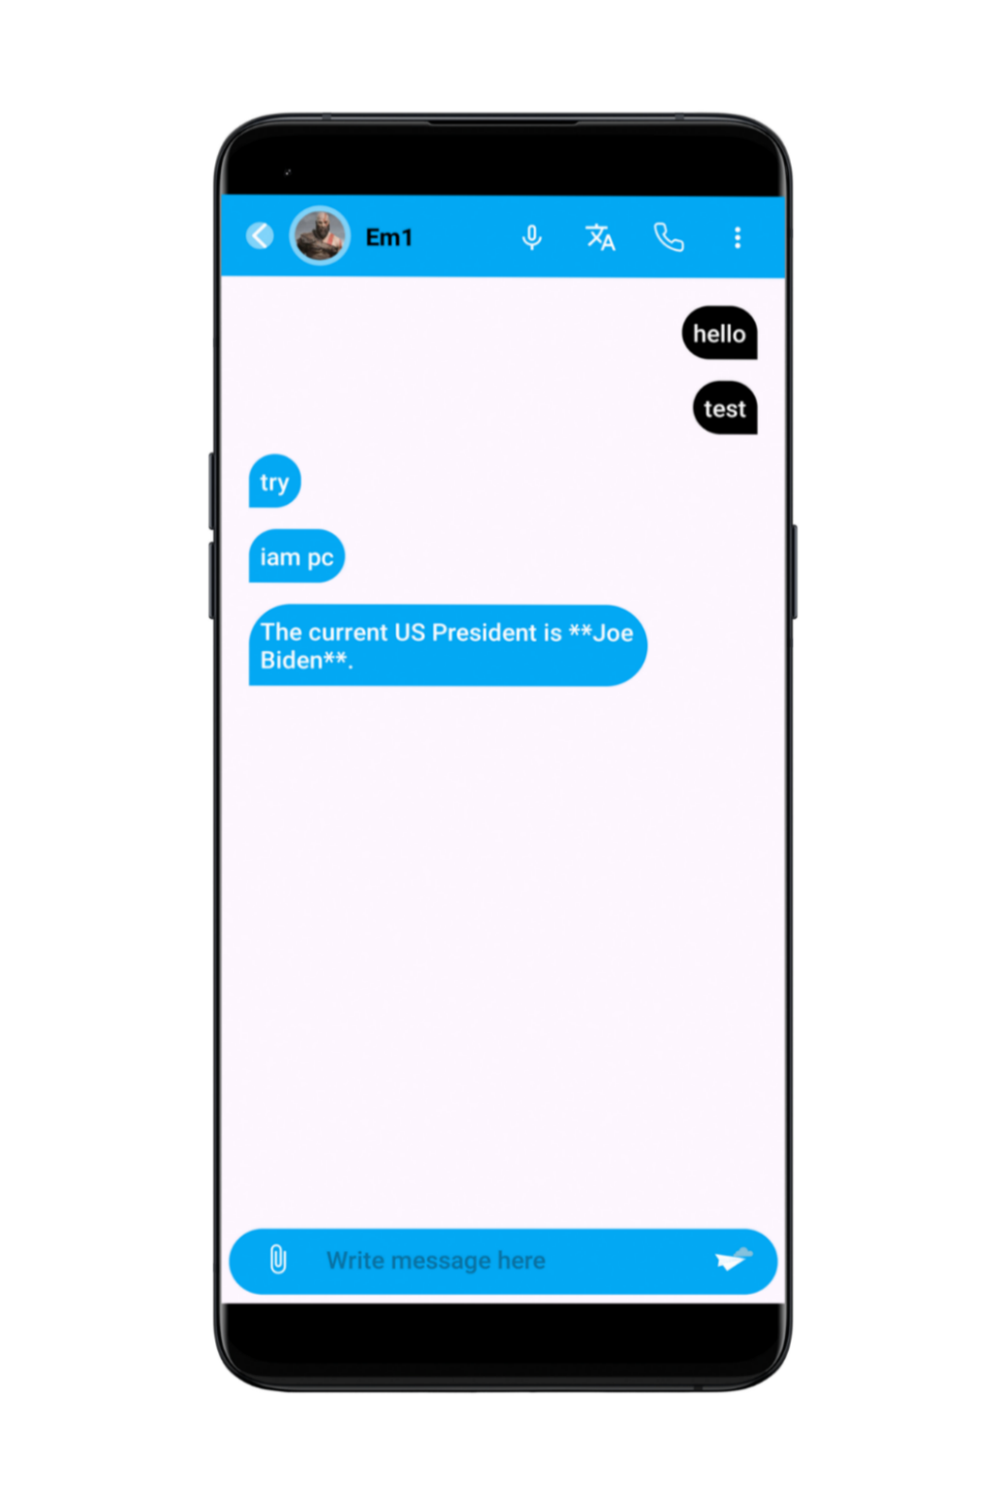

Figure 4‑9 Chat Activity View

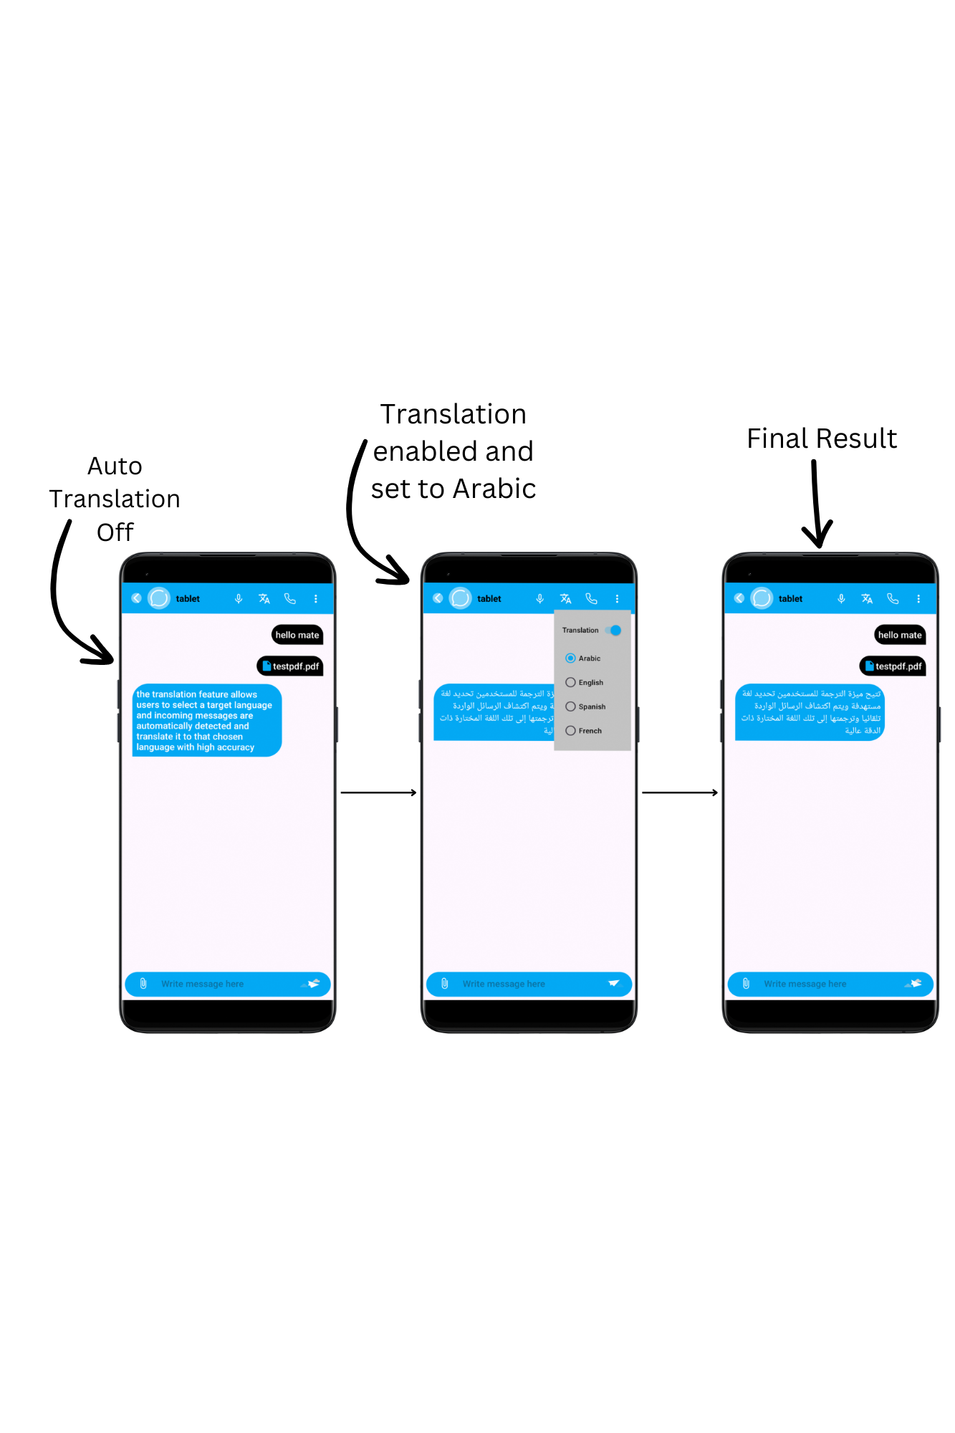

Figure 4‑10 Auto Translation Showcase.

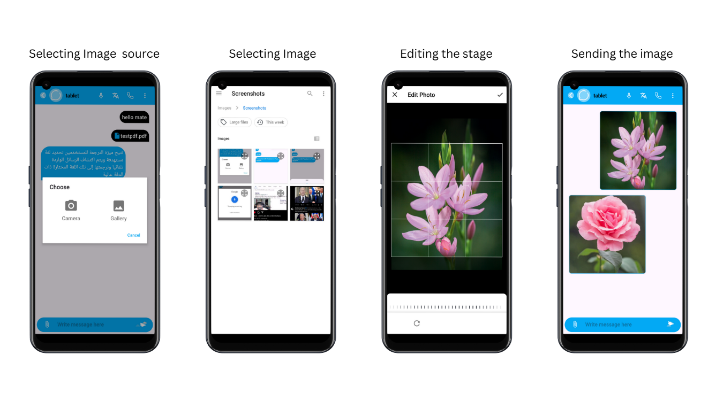

Figure 4‑11 Walkthrough of sending an image

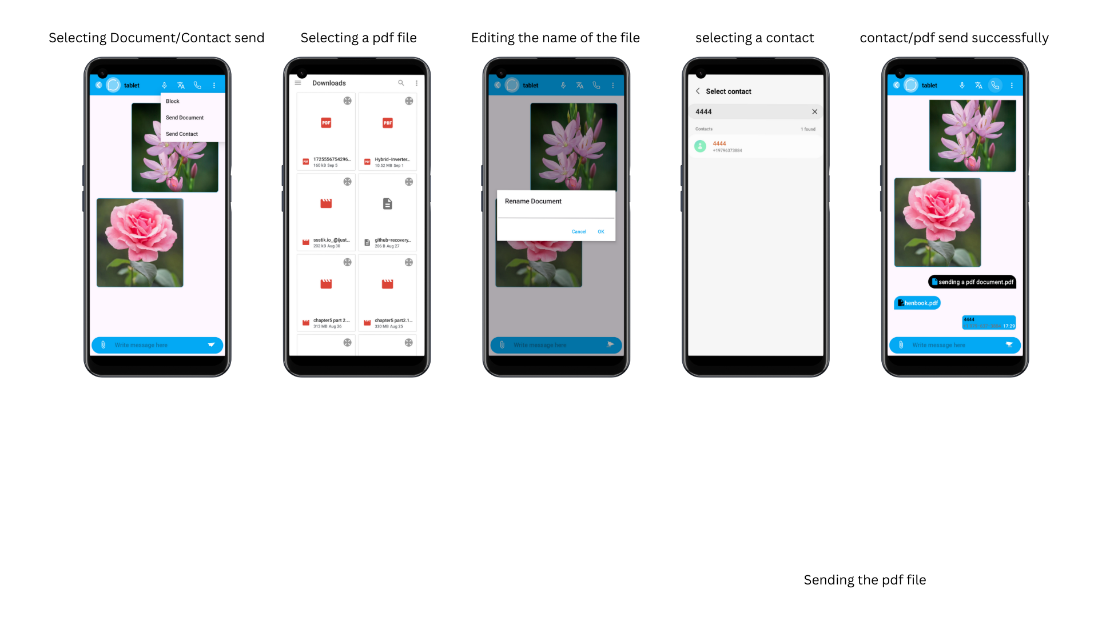

Figure 4‑12 Sending a contact/document process

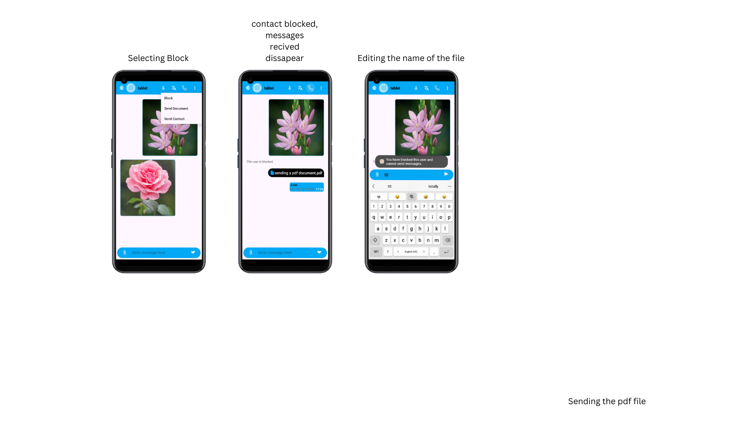

Figure 4‑13 Blocking a contact.

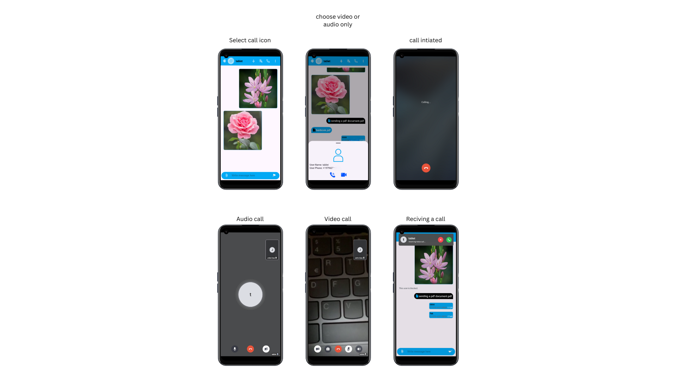

Figure 4‑14 Calling feature walkthrough

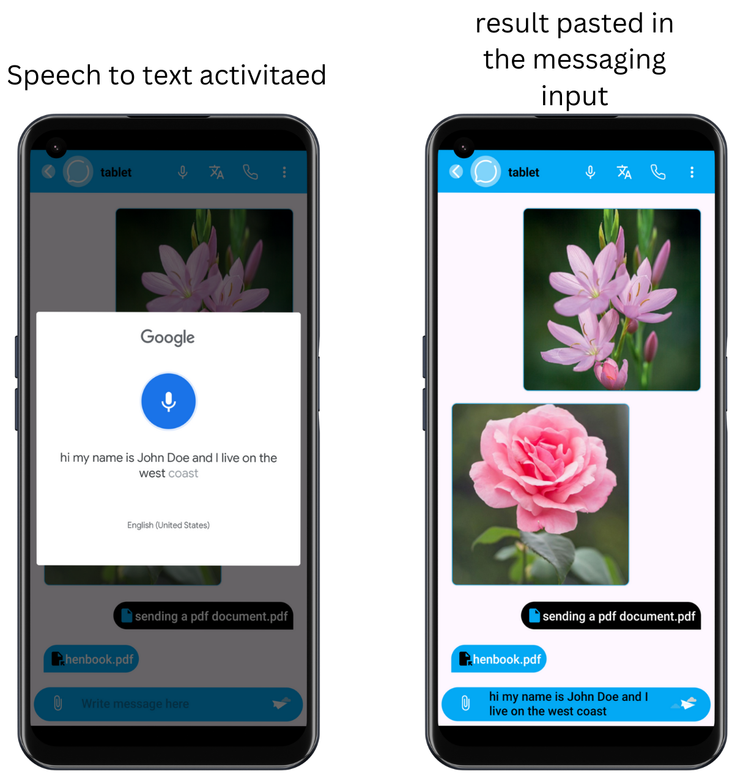

Figure 4‑15 Speech-to-text feature.

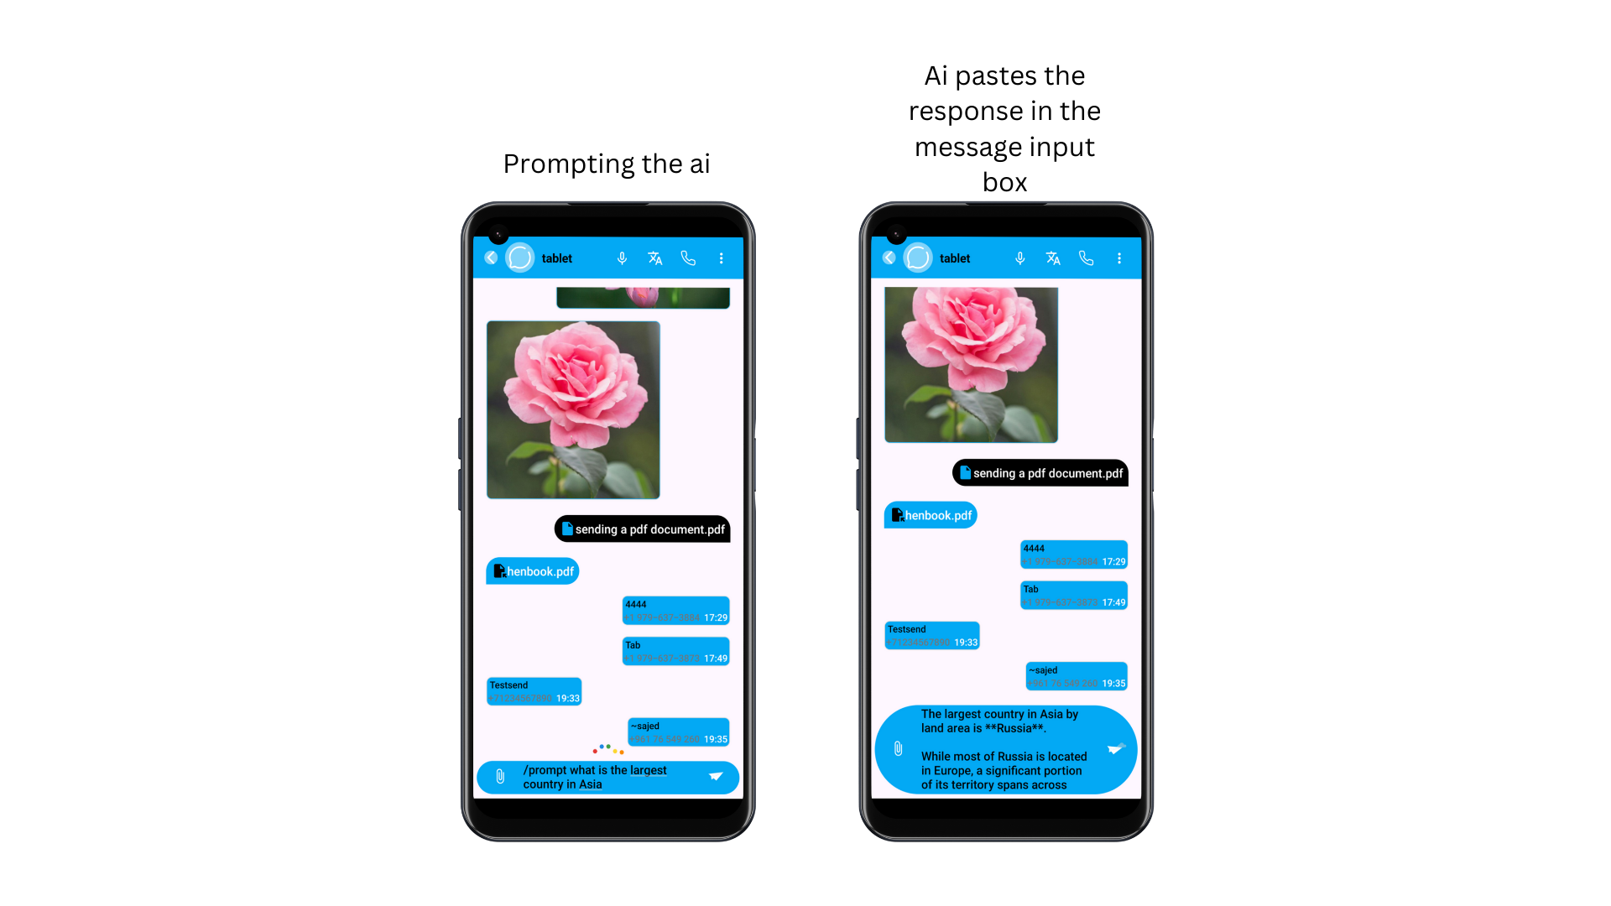

Figure 4‑16 Ai prompting

Group Chat Activity and its features:

**Creating a Group Chat**

To create a group chat, start by clicking on the More Options button in the main activity and selecting Create Group Chat. You will be shown a list of users from your contacts who are using the app. From here, you can select the users you want to add to the group chat. After selecting your contacts, you will be prompted to give the group chat a name. Once you click Create, a new group chat will be created with the chosen members. Figure 4‑17 shows how to create a group chat.

**Messaging and Media Sharing**

In a group chat, users can send text messages, documents, contacts, and images, similar to one-to-one chats. This ensures that the same functionality for seamless communication is available in both individual and group settings. Sending images or documents follows the same process: the user can either choose the media from their gallery, camera or file storage and send it to the group. The shared documents and images will be accessible to all group members. Refer to the one-to-one chat to learn how to send media.

**Calls and Management**

Group chats also support group calls, including both video and audio calls. Using the Zego Cloud API, group calls are facilitated by connecting each user’s Firebase ID, creating a channel between all selected members. This allows users to engage in real-time conversations in larger settings, with the same ease and quality as one-to-one calls.

Users can also manage group members by adding or removing participants as needed. Group administrators can include new members or remove existing ones, allowing for flexible management of group dynamics and participation. Figure 4‑18 displays a group video call.

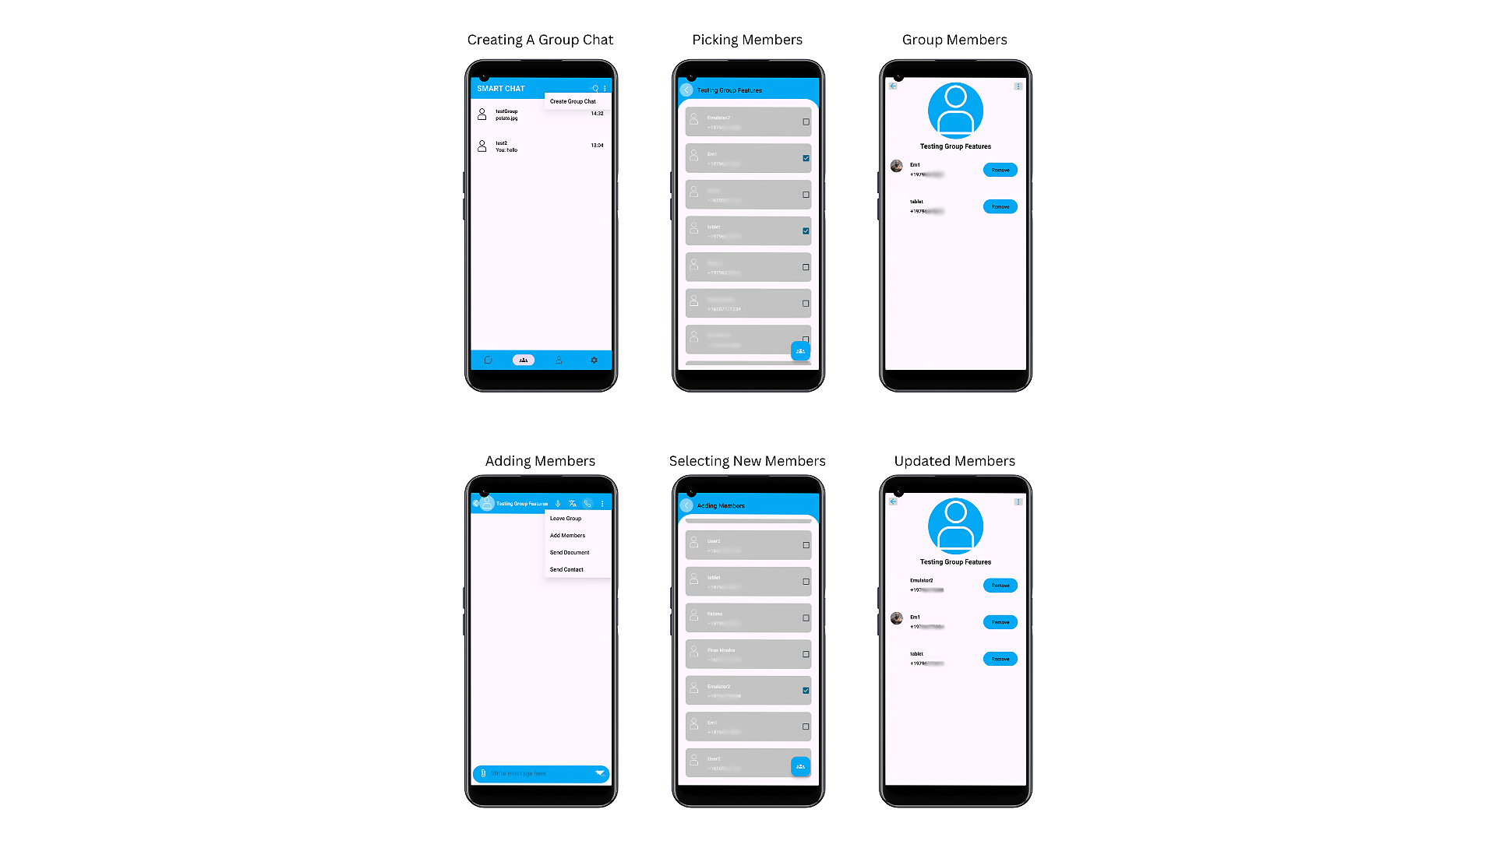

Figure 4‑17 Creating a group chat

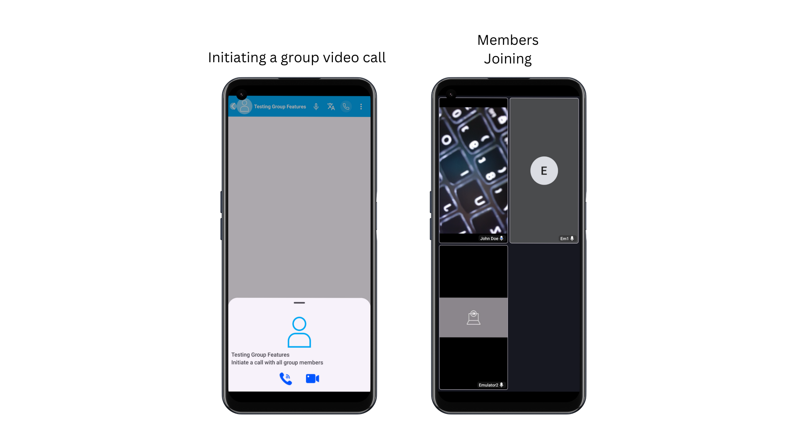

Figure 4‑18 Group video call

Profile Fragment and Its Functionalities

The **Profile Fragment** in **Smart Chat** is where users can manage their personal information, making it visible to others in the app. It serves as a customizable hub for personal settings and preferences, allowing users to update their display name, status, and profile picture, all within a few simple steps.

One key feature of the profile fragment is the ability to **change your username**. This username is what other users will see when interacting with you in chats and group conversations. Simply edit your username to reflect your current preferences, and it will be updated across the app.

Additionally, the **status update** functionality allows users to communicate their availability to others. Whether you're busy and don’t want to be contacted or are available and online, the status lets you share your current activity or mood with your contacts.

Another important feature is the ability to **change your profile picture**. By clicking on the profile picture, you can choose to update it from two sources—either by selecting an image from your gallery or taking a new photo using the camera. After selecting the image, you can review and confirm it before clicking the **Update Profile floating** button. Once updated, your new profile picture will be visible to all users within the app.

In summary, the profile fragment provides an easy and efficient way to manage how you present yourself within Smart Chat, offering the flexibility to adjust your username, status, and profile picture at any time. Figure 4‑19 Demo of updating the profile.

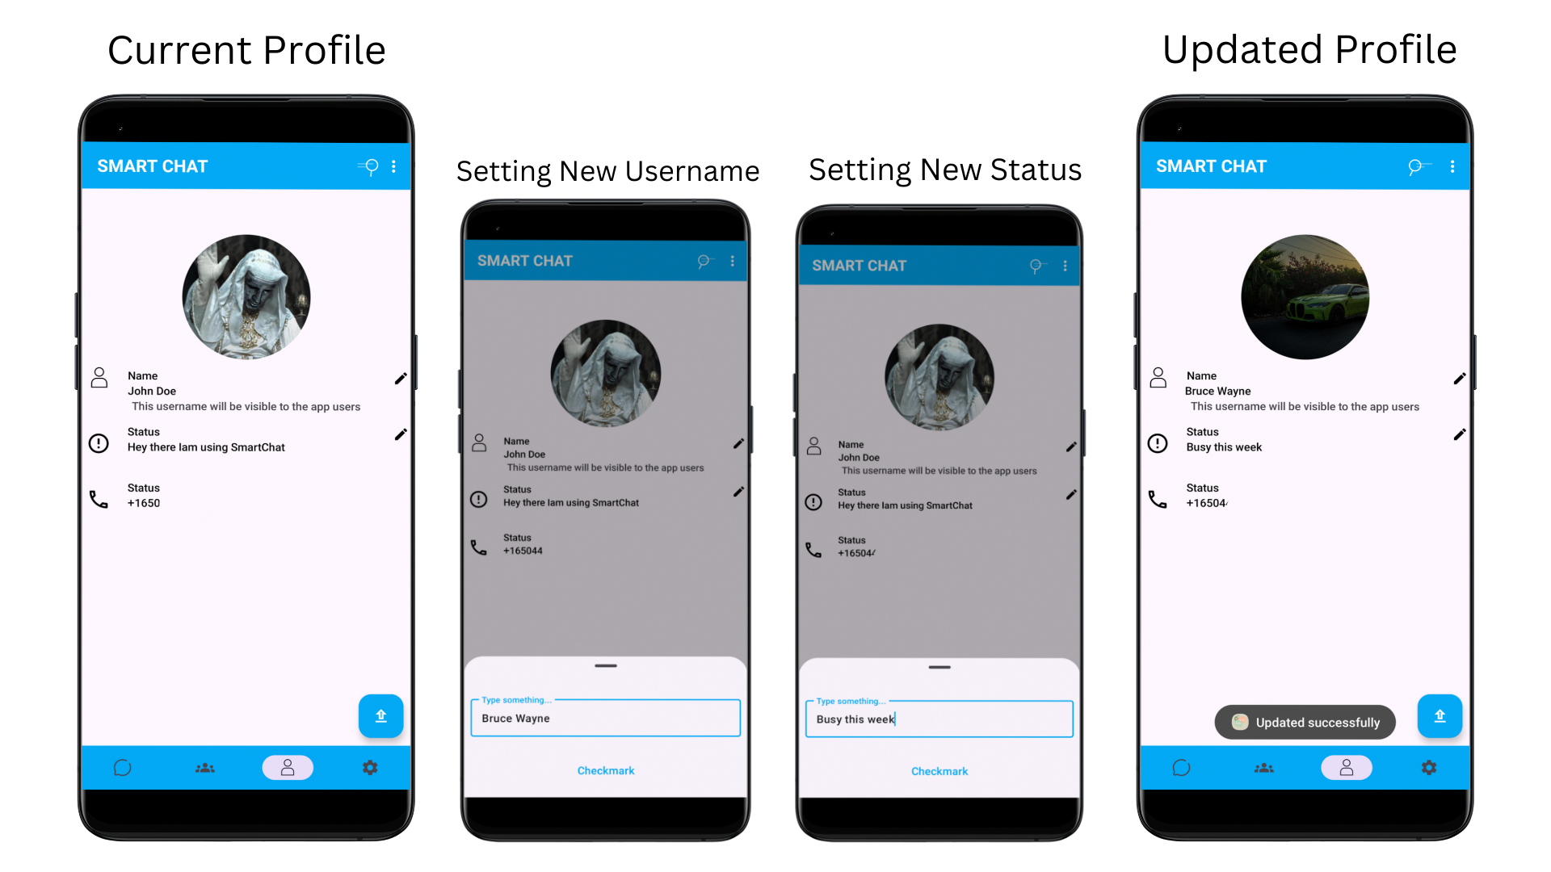

Figure 4‑19 Demo of updating the profile.

Settings Fragment and Its Functionalities

The **Settings Fragment** in **Smart Chat** provides users with important customization and control options to enhance their experience within the app. It offers three functionalities, each aimed at improving usability and optimizing performance. Figure 4‑20 shows the layout of the setting fragment.

The first key feature is the ability to **choose the UI language**. Users can select from four different languages: Spanish, French, Arabic, and English. This multilingual support ensures that users can navigate the app in their preferred language, making it more accessible and user-friendly for a global audience. Figure 4‑21 shows how to change the Ui language.

Another feature within the settings is the option to **turn off animations**. For users looking to save resources such as battery life and system performance, this feature allows them to disable animations throughout the app. By reducing visual effects, the app consumes fewer resources, which can be especially beneficial on devices with limited power or during extended usage periods.

Finally, the **logout functionality** provides a quick and easy way for users to securely log out of the app. By clicking the logout button, users can safely exit their account, ensuring their personal information and chats are protected, especially when using shared devices. See Figure 4‑20 for logout in action.

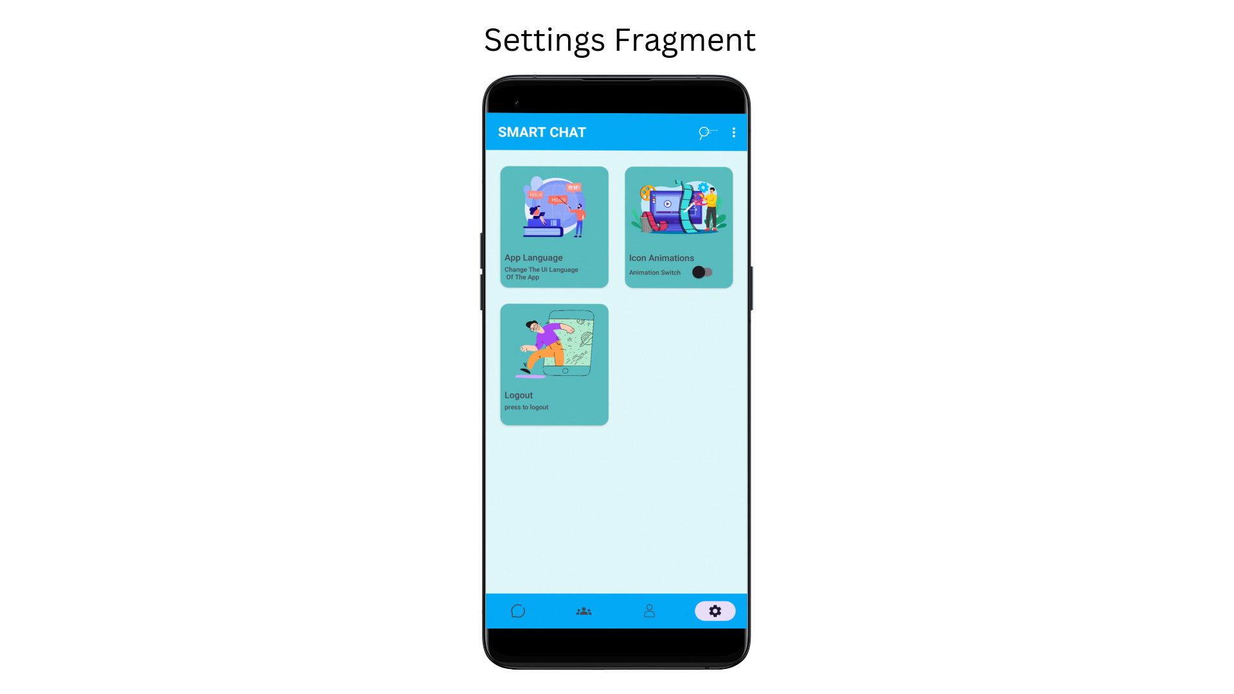

Figure 4‑20 Settings Fragment

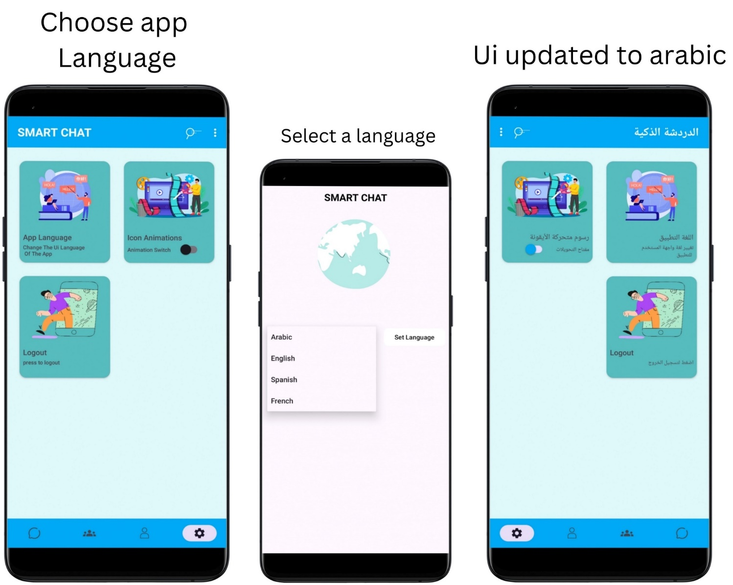

Figure 4‑21 Changing app language functionality

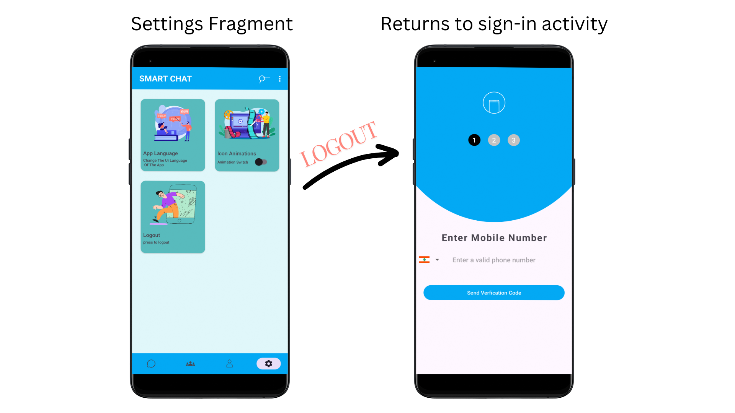

Figure 4‑22 Logout Function

## Test Cases and Acceptance Criteria

Following the app's implementation, we began testing to check that all components and functionalities worked properly.

**Steps:**

* The user enters a valid phone number.
* Firebase servers check if the user is not a robot through reCAPTCHA.
* The user receives a one-time password (OTP) and inputs the correct code.
* After successful OTP verification, the user must enter a username.
* The username must be greater than three characters.

**Expected Outcome:**

* The app successfully verifies the phone number through Firebase.
* CAPTCHA verification ensures the user is human.
* The OTP is validated correctly.
* Upon entering a valid username (greater than three characters), the user is granted access to the app.
* If any validation fails, the user is allowed to resend the verification code and restart the process.

**Acceptance Criteria:**

* The phone number must be valid and follow a standard format.
* The OTP must match the one sent by Firebase within the allowed time frame.
* The username must be at least three characters long.
* Error handling must be in place for incorrect OTPs, invalid phone numbers, or usernames not meeting the character limit.

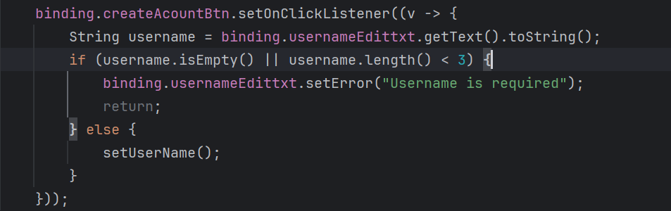

Figure 4‑23 The username must be greater than 3 characters.

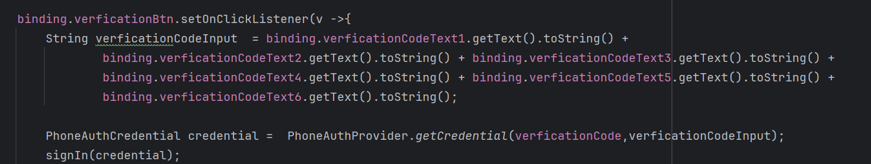

Figure 4‑24 Handling the OTP code

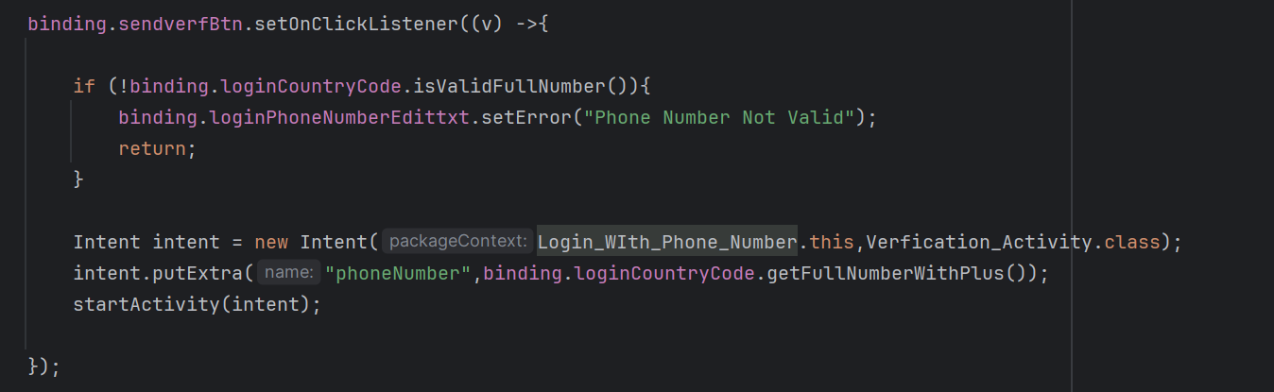

Figure 4‑25 Checking if the phone number is valid

**Test Case 2: Blocking a Contact Functionality**

**Objective:**  
Ensure that when a user blocks a contact, neither party can send messages, documents, contacts, or images to each other.

**Steps:**

1. **User A** blocks **User B** in the chatroom.
2. **User A** tries to send a text message, document, contact, or image to **User B**.
3. **User B** attempts to send a text message, document, contact, or image to **User A** after being blocked.
4. **User B** is notified that they have been blocked by **User A**.

**Expected Outcome:**

* **User A** successfully blocks **User B**.
* Neither **User A** nor **User B** can send any messages (text or media) to each other after the block.
* **User B** receives a notification informing them they have been blocked by **User A**.
* The app prevents the sending of text messages, documents, contacts, or images from either user post-blocking.

**Acceptance Criteria:**

* After blocking, **User A** cannot send messages or any media (documents, contacts, images) to **User B**.
* After blocking, **User B** is prevented from sending messages or any media to **User A**.
* **User B** is notified of being blocked when attempting to send any communication.
* Both users should see an appropriate error message or block indicator when attempting to interact post-blocking.

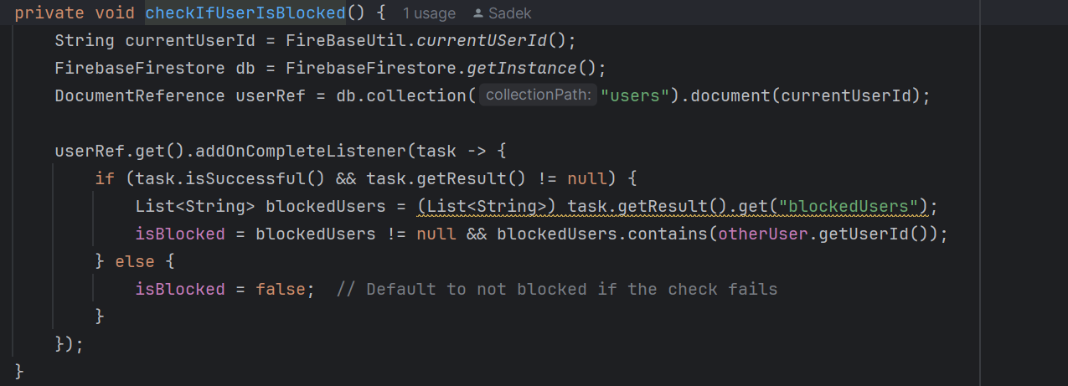

Figure 4‑26 Checking if the user is blocked

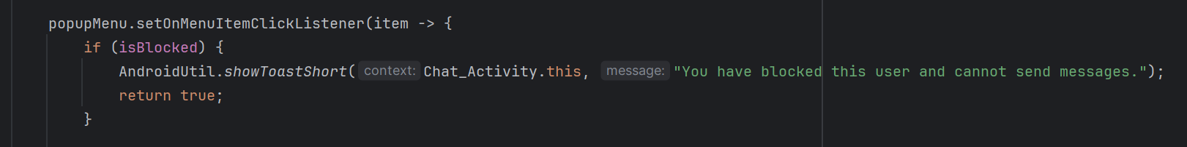

Figure 4‑27 If the user is blocked you will not be able to use the send function.

**Test Case 3: Admin Privileges for Group Chats**

**Objective:**  
 Ensure that when a user enters a group chat, the app correctly identifies whether the user is an admin and grants admin privileges accordingly, including the ability to add or remove members both in the chatroom and group profile.

**Steps:**

1. **User A** (group admin) enters a group chatroom.
2. **User B** (non-admin member) enters the same group chatroom.
3. **User A** attempts to:
   * Add a new member to the group chat.
   * Remove an existing member from the group chat.
4. **User B** attempts the same actions.
5. Both users access the group profile and attempt to:
   * View the member list.
   * Add a member.
   * Remove a member.

**Expected Outcome:**

* **User A** (admin) can add and remove members from the group chatroom and group profile.
* **User B** (non-admin) cannot add or remove members, either in the group chatroom or group profile.
* If **User A** enters the group profile, they see options to add or remove members.
* **User B** does not see these options and cannot modify the group composition.

**Acceptance Criteria:**

* **User A** (admin) is allowed to add or remove members both from the chatroom and group profile.
* **User B** (non-admin) is restricted from performing these actions.
* Group membership changes (addition/removal) are updated in real time and reflected across all users in the group.
* The UI clearly distinguishes admin functionalities (add/remove members) and hides them for non-admin users.



Figure 4‑28 If isAdmin is true the user will be able to add members to the group.

## Conclusion

The development of the Smart Chat App has been a comprehensive and rewarding process, successfully transforming our initial concept into a fully functional, user-friendly communication platform. The implementation phase, executed using Java and XML, involved building essential features such as phone number verification, voice and video calling, and AI-driven functionalities for real-time translation and Speech-To-Text. The inclusion of AI-powered prompts further enhances the user experience, providing contextually relevant suggestions that streamline conversations.

While the implementation phase was not without challenges, particularly in integrating the various technologies and ensuring seamless functionality, each obstacle was addressed through thoughtful research and rigorous testing. The integration of AI for translation and Speech-To-Text function, as well as the voice and video calling features, required careful consideration to maintain system performance and reliability.

Overall, this project highlights the importance of selecting the right tools and technologies, such as Java and XML, to develop a robust, high-quality application. The thorough testing and problem-solving approaches taken during development have resulted in a smart chat app that not only overcomes language barriers but also provides a smooth, efficient communication experience for users across different platforms.

# Conclusion and Future Work

## Conclusion

Developing the Smart Chat App has been a valuable experience, showing how technology can improve communication across different languages. Throughout this project and despite the challenges posed by limited resources, we were able to create a functional and user-friendly app that connects individuals tackling the challenges of adding AI to provide real-time translation, making it easier for people to connect regardless of the language they speak.

Through this project, we have gained insights into the complexities of developing a service-oriented platform and the importance of prioritizing user needs and preferences. One of the key lessons learned is the significance of effective communication and collaboration. As a team, we navigated through various tasks and challenges by maintaining open lines of communication, sharing ideas, and leveraging each other's expertise. This experience highlighted the importance of teamwork and coordination in achieving project goals.

Moreover, A major lesson from this project was understanding the power of AI to solve practical problems. By adding a translation feature to our chat app, we helped users communicate smoothly in various languages, which made conversations more inclusive and accessible. This experience highlighted how important it is to use technology to meet diverse user needs and improve their experience.

In addition, The Smart Chat project provided us with valuable experience in mobile development, UI/UX design, and database management. We gained expertise in creating user-friendly interfaces, optimizing mobile performance, and implementing efficient data management practices. We learned the importance of continuous improvement in user experience through user feedback, usability testing, and monitoring user behavior. Overall, the project equipped us with the necessary skills to deliver high-quality mobile applications and enhance user satisfaction in the future.

In summary, the Smart Chat App has shown us how technology can break down language barriers and improve communication. The challenges we faced and the solutions we found have given us valuable skills and insights. We’re excited about the potential of this project and look forward to seeing how it can make a positive impact on users around the world.

## Future Work

Many features were considered for inclusion in this project during development, but owing to time and resource constraints, we were only able to include a few of them. The rest of the features in the plan are:

1. Accessibility Features: Enhance accessibility by incorporating features such as text-to-speech, image generation, and visual enhancements and filters. This ensures that the app is inclusive and usable by everyone.

2. Smart Notification Management: Develop an AI system that intelligently manages notifications based on user preferences and conversation importance. This feature can help users prioritize messages and reduce notification overload.

3. Smart Suggestions and Replies: Develop AI-driven smart suggestions for replies based on the context of the conversation. This feature can offer quick, relevant responses and help users maintain engaging and timely interactions.

4. AI-Driven Content Moderation: Develop AI tools to automatically detect and moderate inappropriate or harmful content in real time, ensuring a safer and more respectful communication environment.

5. AI-Powered Conversation Summaries: Implement a feature where the AI provides summaries of long conversations. This could be useful for users who need quick overviews of discussions, especially in group chat.

By focusing on these potential features, the Smart Chat App can become even more powerful and user-friendly, helping users communicate more effectively.

**APPENDIX A:   
Implementation Details**

**Message Encryption and Decryption:**

In Smart Chat, messages between users are encrypted before being uploaded to Firebase, ensuring security and confidentiality. Below is the process and code used to achieve message encryption and decryption.

When a user sends a message, the Firebase ID of the recipient is used as the public identifier. This Firebase ID, combined with other encryption techniques, generates a private key for securing the message. The message is then encrypted using this private key. On the receiving end, the recipient fetches the public Firebase ID of the sender from the message and uses the same encryption algorithm to generate the private key, which is then used to decrypt the message.

**How it works:**  
  
When User One sends a message to User Two, the following steps occur for encryption and decryption:

1. **Retrieving Firebase ID**:
   * The chatroom ID, which is uniquely generated by Firebase, includes the Firebase IDs of both users.
   * From this chatroom ID, **User Two's** Firebase ID is retrieved by **User One**.
2. **Encrypting the Message**:
   * **User One** uses **User Two's** Firebase ID to generate a private key for encrypting the message.
   * The message is encrypted using this key, ensuring that only **User Two** can decrypt it.
   * The encrypted message is then sent and uploaded to Firebase.
3. **Decryption on Receiver Side**:
   * When **User Two** receives the message, they use their own Firebase ID to generate the private key.
   * This private key is used to decrypt the message, making the content readable for **User Two** in their chatroom.

Methods used to generate the private key are confidential.

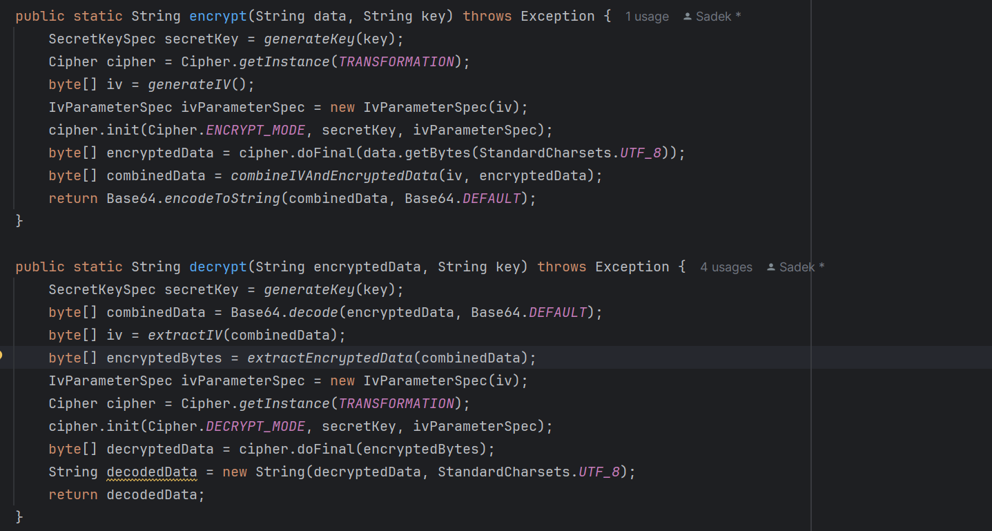

Figure 5‑1 Methods used to encrypt and decrypt data

**How Notifications Work:**

**OneSignal Integration**:

* + The app uses the OneSignal API to send notifications to users. This is handled via the OneSignalManager class.
  + Notifications are sent to users through the OneSignal platform using HTTP requests in JSON format.

**Sending a Notification**:

* + The send notification () method takes three parameters: the title of the notification, the message content, and the recipient’s external ID (which is the unique identifier assigned by OneSignal to each user).
  + The notification is formatted as a JSON object containing:
    - The app_id (unique to your OneSignal app),
    - The notification content (title and message),
    - The target_channel (in this case, push notifications),
    - The external ID of the recipient.

**Executor Service**:

* + The executor is used to run the HTTP request on a separate thread, ensuring that the notification-sending process does not block the main thread of the app.

**OkHttpClient**:

* + An instance of OkHttpClient is created to make an HTTP POST request to OneSignal’s notification API.
  + The JSON object is sent as the body of the request, and the necessary headers are added (Content-Type and Authorization).

**Response Handling**:

* + The app waits for the response from OneSignal, indicating whether the notification was sent successfully or if there was an error. Success or error messages are printed in the console accordingly.

**How Notifications Function in Practice:**

* **Message Sending**: When **User One** sends a message to **User Two**, if **User Two** is offline, a push notification will be triggered.
* **Notification Content**: The message will be included in the notification, along with the name of the sender, and delivered via OneSignal to **User Two’s** device.
* **API Key & App ID**: These are used to authorize the app to send notifications via the OneSignal platform, making sure only legitimate requests are processed.

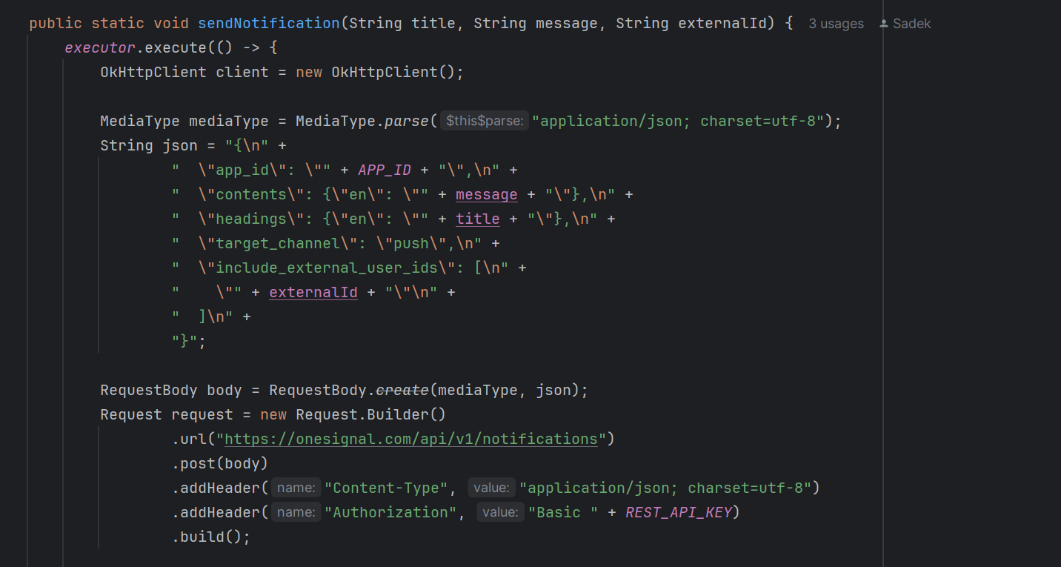

Figure 5‑2 Sending notifications using OneSignal.

**APPENDIX B:  
 USER Manual**

**User Manual: Smart Chat.**

1. **Introduction**

Greetings from the Smart Chat developers! With the help of this user manual, you can connect, communicate, and work with friends, family, and coworkers more quickly and securely thanks to the Smart Chat app's features and functionalities. Smart Chat offers an easy and safe messaging solution that keeps you connected, whether you want to remain in touch, create group chats, or exchange vital updates.

1. **Getting Started**
   1. Signing up:

All you need to sign up for Smart Chat is your phone number. You are required to enter your phone number into the app to get a verification code that is delivered to your phone via SMS. You'll be prompted to create a username after your number has been validated. After setting your username, you're ready to start using Smart Chat and connect with your contacts. It's that simple—no extra details needed!

* 1. Logging in:

The log in process in Smart Chat is just as simple as signing up. Enter your phone number, and once verified, your previous username will automatically appear. You can choose to keep your existing username or edit it to something new before logging in. This flexibility makes getting back into Smart Chat quick and effortless.

1. **Starting a chatroom**
   1. One to One:

Go to the main app interface of Smart Chat and select the search icon to start a one-to-one conversation. From there, you have two options: click on the contacts button to show app users from your list of contacts, or search for the user by entering their username or phone number. Once you've located the person you want to message, all you have to do is click on their profile to open a chat window and start conversing.

* 1. Group chat:

In Smart Chat, click "More Options" from the main menu and choose "Create Group Chat" to start a group chat. You can choose which contacts you wish to add to the group by selecting them from the list that displays. Once you've chosen your participants, give your group chat a name, and then click "Create" to create it.

1. **Features**
   1. Translation:

To use the translation feature in Smart Chat, enter the chatroom where you want to enable translation. Click on the translation button located on the toolbar, toggle the feature on, and choose your preferred language. Once activated, the required language model will be downloaded, and incoming messages will be automatically translated into the selected language. You can change the language anytime by revisiting the translation settings.

* 1. Ai prompting:

To utilize the AI feature in Smart Chat, simply type /prompt in the message input field followed by your query. The AI will process your request, and the generated response will be displayed in the message input area. You can then opt to send the answer or remove it.

* 1. Speech to text:

Click the microphone icon in the toolbar and recite your message to utilize Smart Chat's speech-to-text capability. When you're finished, the text you've transcribed will show up in the message input form and will be ready to be sent.

* 1. One-to-one call:

To use the one-to-one call feature in Smart Chat, enter a one-to-one chatroom and click the call icon. You’ll be prompted to choose either a voice call or a video call. Once you make your selection, the call will start immediately.

* 1. Group call:

For the group call feature in Smart Chat, enter a group chat and click the call icon. You’ll be given the option to start either a voice call or a video call with the group. After selecting your preferred call type, the group call will begin, allowing all members to join in or decline.

* 1. Sending a picture:

For the picture-sending feature in Smart Chat, click the attachment button in the chatroom and choose either the camera or gallery as the source. Once you've selected or captured a picture, you'll have the option to edit its dimensions. After making the adjustments, click the checkmark, and the image will be sent to the chatroom you've chosen.

* 1. Sending a document:

To send a document, navigate to the toolbar and click on 'More Options'. From the dropdown menu, select 'Send a Document'. This will prompt you to choose a file from your device's storage. Browse through your files and select the document you wish to send. Once selected, the document will be sent successfully. This feature allows you to easily share documents with others directly from the app.

* 1. Sending a contact:

To share a contact, access the toolbar and click on 'Send Contact'. This will open your device's contact list. Browse through your contacts and select the one you wish to share. Once selected, the contact information will be sent successfully. This feature enables you to quickly share contact details with others directly from the app.

* 1. Blocking a user:

To block a user in a one-on-one chatroom, go to the toolbar and choose 'More Options'. From the dropdown option, choose 'Block'. This prevents the individual from contacting you and sending you messages. Once blocked, the user will be unable to begin chats with you, resulting in a more secure and controlled chatting experience.

* 1. Group admin rights:

You possess special rights as a group admin, which lets you run the group efficiently. You can add new members, remove existing ones from the group, and even change the group name using these capabilities.

1. **Profile:**
   1. Setting/changing a profile Image:

To set or change your profile image, follow these steps. Click on your current profile picture, then choose the source of the new image: either take a new photo using your camera or select an existing one from your gallery. Select the desired image and click the checkmark to confirm and save the changes. By following these steps, you can easily update your profile image and showcase your new look within the app.

* 1. Changing username/status:

To make changes to your username or status, simply click on the input field that corresponds to the desired change in information. After entering the new data, you wish to see, click "Update Profile" to save the modifications to the database. You may quickly update your username and status by following these steps.

1. **Settings**
   1. App language:

To change the language of the app's user interface, simply select your preferred language from the options provided, which include Spanish, Arabic, English, and French. Once you've made your selection, the app's language will be updated and saved, allowing you to navigate the app in your chosen language.

* 1. Animations:

You can customize your app experience by turning icon animations on or off. This feature allows you to personalize the visual effects of the app to your liking and allows saving battery and resources.

* 1. Logout:

If you need to log out of your account, you can do so easily by clicking on the "Logout" option. This will securely sign you out of your account, and you will need to log back in to access the app's features again.

**APPENDIXC:   
deployment and configuration Manual**

1. **Prerequisites**

Before proceeding with the deployment and configuration of the Smart Chat app, ensure that you have Android Studio installed on your development machine. This is a necessary step to ensure a smooth setup process.

1. **Setting up the Android Project**

To set up the Android project, follow these steps. First, open Android Studio and import the Smart Chat project. Next, ensure that you have the necessary Android SDK versions and dependencies installed. Android Studio will prompt you to install any missing components. Finally, open the "build. gradle" file for the app module and build the project.

1. **Building and Running the App**

To build and run the app, follow these steps. First, connect an Android device or start an emulator (Android 7 and above) . Then, click on the "Run" button in Android Studio to build and install the app on the connected device or emulator. Once the app is installed, launch it on the device to start using it.

1. **Troubleshooting Techniques**

If you encounter any issues during the deployment and configuration process, refer to these troubleshooting techniques. If you encounter build errors in Android Studio, make sure that all dependencies are properly configured and that the necessary SDK versions are installed. Additionally, if you have any login issues, make sure you use a valid phone number and enter the right OTP code.

# References

|  |  |
| --- | --- |
| [1] | A. Petrosyan, "statista," 22 May 2024. [Online]. Available: https://www.statista.com/statistics/273018/number-of-internet-users-worldwide/. [Accessed 11 July 2024]. |
| [2] | T. Marks, "One year after its launch, Discord is the best VoIP service available," 13 May 2016. [Online]. Available: https://www.pcgamer.com/one-year-after-its-launch-discord-is-the-best-voip-service-available/. [Accessed 11 July 2024]. |
| [3] | S. Rodriguez, "Discord is rapidly expanding beyond gaming, attracting suitors like Sony and Microsoft," CNBC, 2021. |
| [4] | I. S. Becker and D. Harwell, "How a tiny company with few rules is making fake images go mainstream," 30 March 2023. [Online]. Available: https://www.washingtonpost.com/technology/2023/03/30/midjourney-ai-image-generation-rules/. [Accessed 11 July 2024]. |
| [5] | G. Bridge and B. Bro, "Gravelbridge/Ai-Discord-Mod: An AI-powered discord server moderator capable of moderating text and images," 16 May 2023. [Online]. Available: https://github.com/gravelBridge/AI-Discord-Mod. [Accessed 11 July 2024]. |
| [6] | I. Mehta, "TNW," 14 Augest 2020. [Online]. Available: https://thenextweb.com/news/telegram-introduces-end-to-end-encrypted-video-calls. [Accessed 11 July 2024]. |
| [7] | P. Larsen, "Getting started," [Online]. Available: https://missrose.org/docs/getting-started/. |
| [8] | K. Sukhanova, "Eddy Travels: Find Travel Deals and Make Some Money," 13 December 2021. |
| [9] | E. Florence, "Telegram Messenger Review," 7 January 2022. [Online]. Available: https://cyberinsider.com/secure-encrypted-messaging-app/telegram/#:~:text=Telegram%20security,Wikipedia%20page. [Accessed 11 July 2024]. |
| [10] | B. Stegner, "6 Reasons Why You Might Want to Stop Using Telegram," 15 September 2023. [Online]. Available: https://www.makeuseof.com/reasons-stop-using-telegram/#:~:text=However%2C%20these%20messages%20sit%20on%20the%20server%20so%20you%20can%20access%20them%20from%20multiple%20devices.%20A%20breach%20of%20Telegram%27s%20servers%20could%20thus%20result%20in%20. [Accessed 11 July 2024]. |
| [11] | GilPress, "WhatsApp Statistics, Users, Demographics as of 2024," Big Data, 2023. |
| [12] | L. Ceci, "App tracking and mobile privacy - Statistics & Facts," Statista, 2024. |
| [13] | GABRIELLA, "How to Use Telegram for Customer Support," 5 July 2022. [Online]. Available: https://respond.io/blog/telegram-support. |
| [14] | A. Sundaravelu, "METRO," 16 November 2022. [Online]. Available: https://metro.co.uk/2022/11/16/what-is-discord-the-popular-chat-app-used-by-gamers-17769256/. [Accessed 11 July 2024]. |
| [15] | P. Larsen, "MissRose," [Online]. Available: https://missrose.org/. [Accessed 11 July 2024]. |
| [16] | A. Cooban, "Meta accused of ‘massive, illegal’ data processing by European consumer groups," CNN, London, 2024. |